CS-4513-001

FALL 2023

Professor Gruenwald

Gabriel Owen

113591849

[Gabriel.d.owen-1@ou.edu](mailto:Gabriel.d.owen-1@ou.edu)

DBMS Individual Project

**Tasks Performed**

Task 1. ER Diagram, page: 3

Task 2. Relational Database Schemas, page: 4

Task 3. Page 5

3.1.  Discussion of storage structures for tables

3.2.  Discussion of storage structures for tables (Azure SQL Database)

Task 4 SQL statements and screenshots showing the creation of tables in Azure

SQL Database, page:6-13

Task 5.

5,1 SQL statements **(and Transact SQL stored procedures, if any**) page 13-28

Implementing all queries (1-15 and error checking)

5,2 The Java source program and screenshots showing page 29

its successful compilation Java program Execution page 30-60

Task 6.

6.1. Screenshots showing the testing of query 1 page 30-31

6.2. Screenshots showing the testing of query 2 page 32-33

6.3. Screenshots showing the testing of query 3 page 34-35

6.4. Screenshots showing the testing of query 4 page 35-36

6.5. Screenshots showing the testing of query 5 page 37-38

6.6. Screenshots showing the testing of query 6 page 38-39

6.7. Screenshots showing the testing of query 7 page 40-41

6.8. Screenshots showing the testing of query 8 page 42-43

6.9. Screenshots showing the testing of query 9 page 44-45

6.10. Screenshots showing the testing of query 10 page 46-47

6.11 Screenshots showing the testing of query 11 page 48-49

6.12. Screenshots showing the testing of query 12 page 50-51

6.13. Screenshots showing the testing of query 13 page 52-53

6.14. Screenshots showing the testing of query 14 page 54-56  
6.15. Screenshots showing the testing of the import and export options page 56-57  
6.16. Screenshots showing the testing of three types of errors page 58-59

6.17. Screenshots showing the testing of the quit option page 60

Task 7. Web database application and its execution page 60-63

7.1. Web database application source program and screenshots showing

Its successful compilation  
7.2. Screenshots showing the testing of the Web database application

TASK 1: ER diagram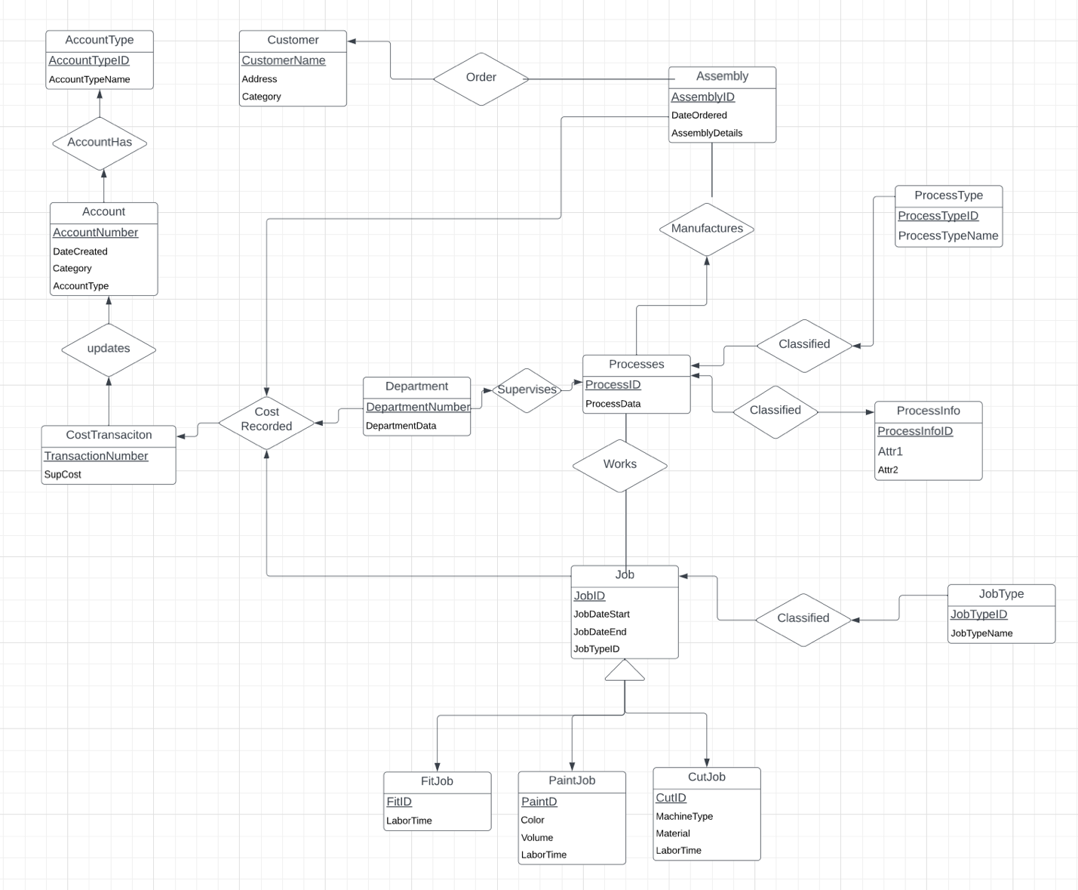

TASK 2:

* Customer(CustomerName: string, Address: string, Category: int)
* Assembly(AssemblyID:int, DateOrdered: date, AssemblyDetails: string, CustomerName: String, AccountNumber: int)
* AssemblyXREF(ProcessID: int, AssemblyID: int)
* Process(ProcessID: int,ProcessData: String, AssemblyID: int, ProcessInfoID: int, ProcessTypeID: int, DepertmentNumber: int, accountNumber: int)
* ProcessType(ProcessTypeID: int, ProcessType: string)
* ProcessInfo(ProcessInfoID: int, Attr1: String, Attr2: String)
* Job(JobID: int, JobDateStart: Date, JobDateEnd: Date, JobTypeID: int, ProcessID: int, assemblyID: int, LaborTime:float)
* JobType(JobTypeID: int, JobTypeName: string)
* JobFit(JobID: int)
* JobPaint(JobID: int, Color: string, Volume: float)
* JobCut(JobID: int, MachineType: string, Material: string)
* CostTransaction(TransactionNumber: int, SupCost: float, JobID: int, ProcessAccountID: int, DepartmentAccountID: int, AssemblyAccountID: int)
* Account(AccountNumber: Int, DateCreated: Date, Details: float, AccountTypeID: int)
* AccountType(AccountTypeID: int, AccountTypeName: string)
* Department(DepartmentNumber: int, DepartmentData: string, AccountNumber: int)

TASK 3: Storage Structures

|  |  |  |  |  |  |
| --- | --- | --- | --- | --- | --- |
| Table Name | Query Number and Type | SearchKey | Query Frequency | Selected File Organization | Justifications |
| Account | 5 INSERT  8 INSERT  9 JOIN | AccountID | 10/Day  50/day  200/day | clustered | Access mutliple different tables |
| AccountType |  |  |  | Heap | Only need account table |
| Assembly | 4 INSERT  5 UPDATE  6 SELECT  8 JOIN  9 JOIN  11 JOIN | AssemblyID | 40/day  10/day  50/day  50/day  200/day  100/day | Heap | Relates almost soley to xref table |
| AssemblyXREF | 4 INSERT  8 JOIN  11 JOIN | ProcessID, AssemblyID | 40/day  50/day  100/day | Clustered | Will be used a lot to join process and assembly |
| CostTrasaction | 8 INSERT  13 DELETE |  | 50/day  1/month |  |  |
| Customer | 1 INSERT  4 SELECT  12 SELECT | CustomerName | 30/Day 40/day  100/day | heap | Most frequenlty used just for select |
| Department | 2 INSERT  3 SELECT  5 UPDATE  8 JOIN  10 JOIN | DepartmentNumber | Infrequent  Infrequent  10/day  50/day  20/day | heap | Not as many references as other table and usually only selecting one row. |
| Job | 6 INSERT  7 UPDATE  8 JOIN  10 JOIN  11 JOIN  13 DELETE | JobID | 50/day  50/day  50/day  20/day  100/day  1/month | clustered | jobID may be the most used and looked up individual attribute |
| JobCut | 7 INSERT  13 DELETE | JobID | 17/day  1/month | Heap | Goes only to job table |
| JobFit | 7 INSERT | JobID | 17/day | Heap | Goes only to job table |
| JobPaint | 7 INSERT  14 UPDATE | JobID | 17/day  1/week | heap | Goes only to job table |
| Process | 3 INSERT  5 UPDATE  6 SELECT  8 JOIN  10 JOIN  11 JOIN | ProcessID | Infrequent  10/day  50/day  50/day  20/day  100/day | heap | Relates almost soley to xref table |
| ProcessInfo | 3 INSERT | ProcessInfoID | Infrequent | Heap | Only access process table |
| ProcessType | 3 INSERT | ProcessTypeID | Infrequent | heap | Only access process table |

TASK 4: Create Tables

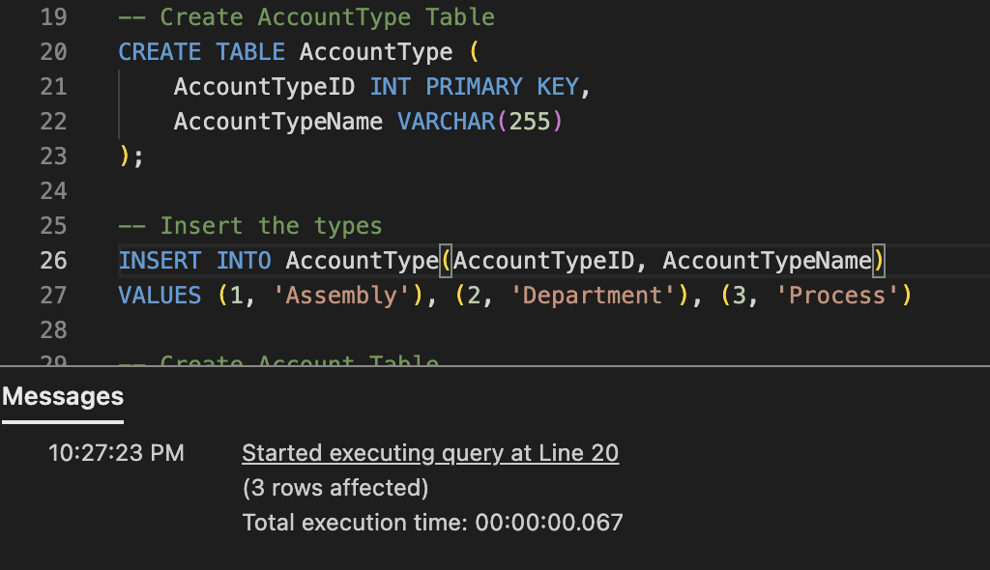

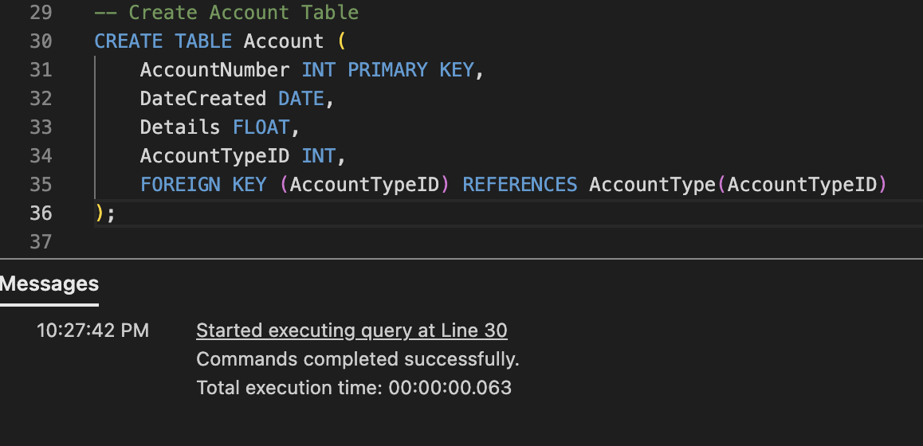

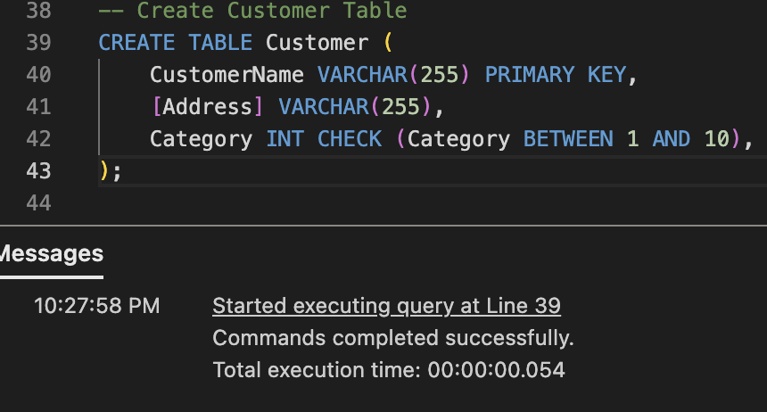

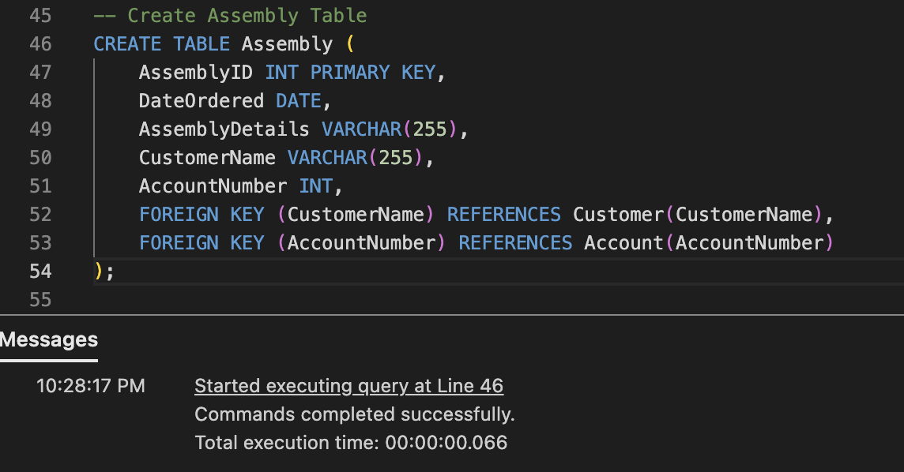

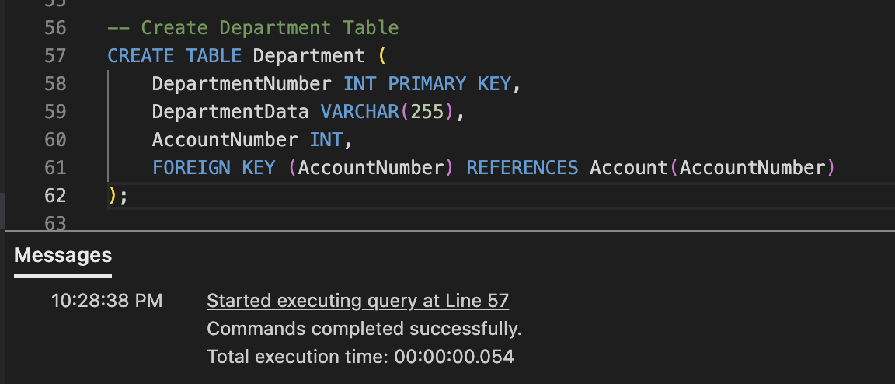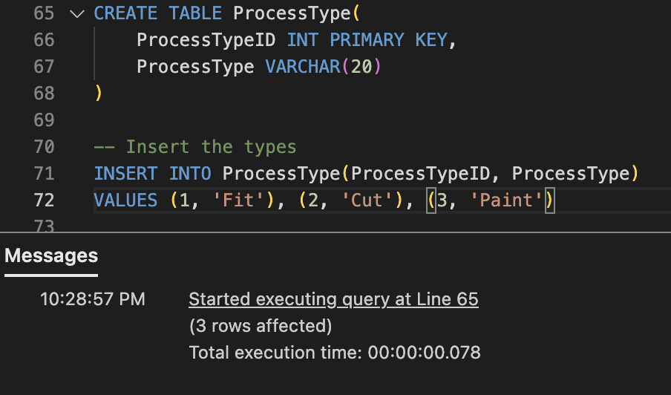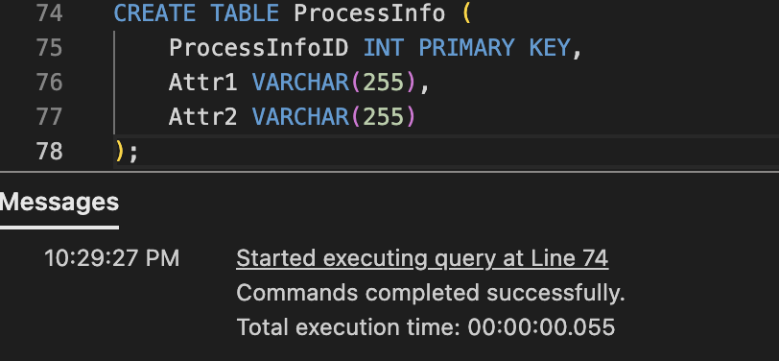

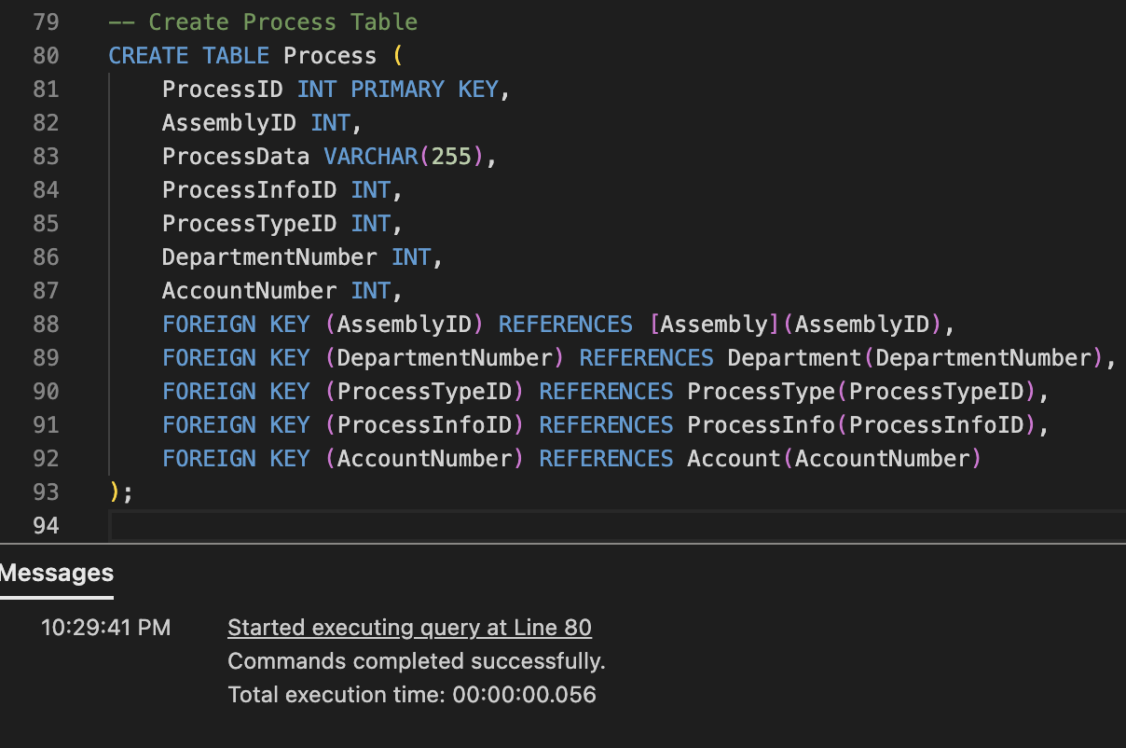

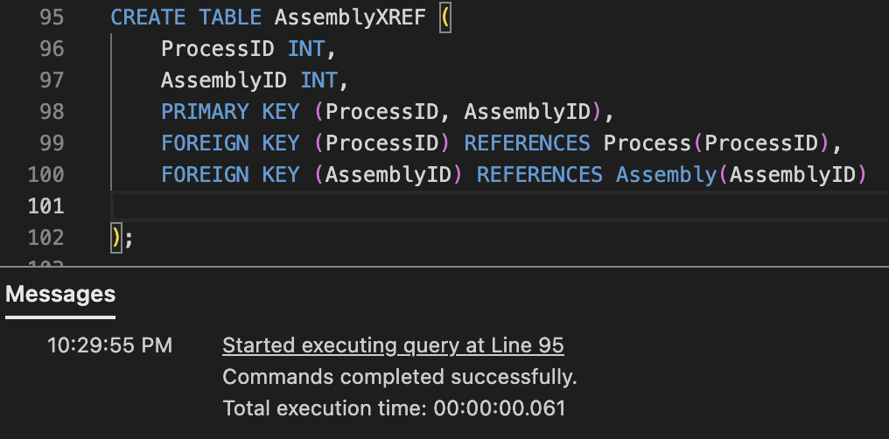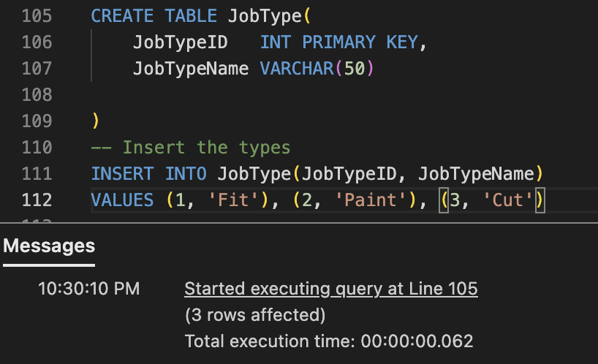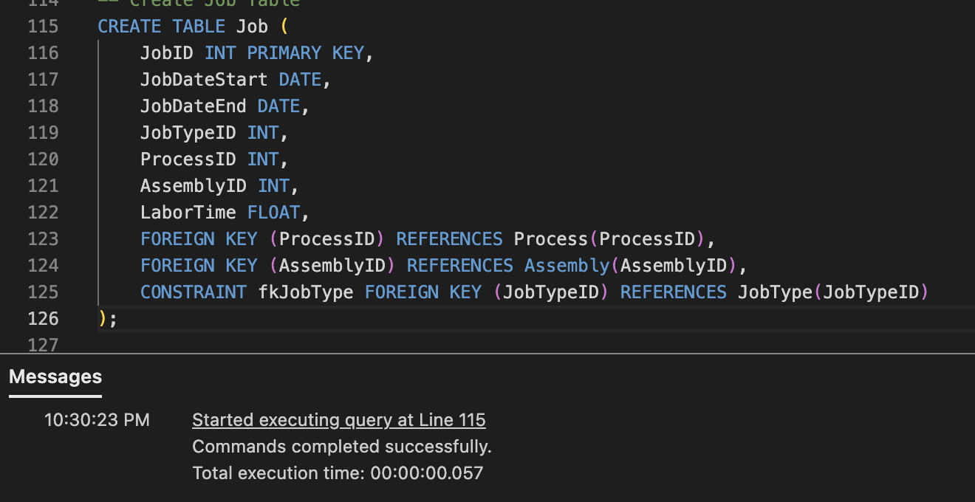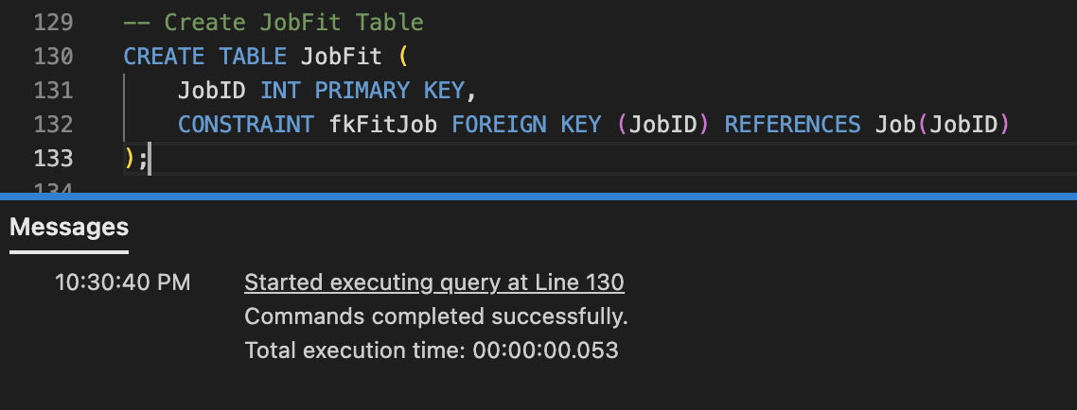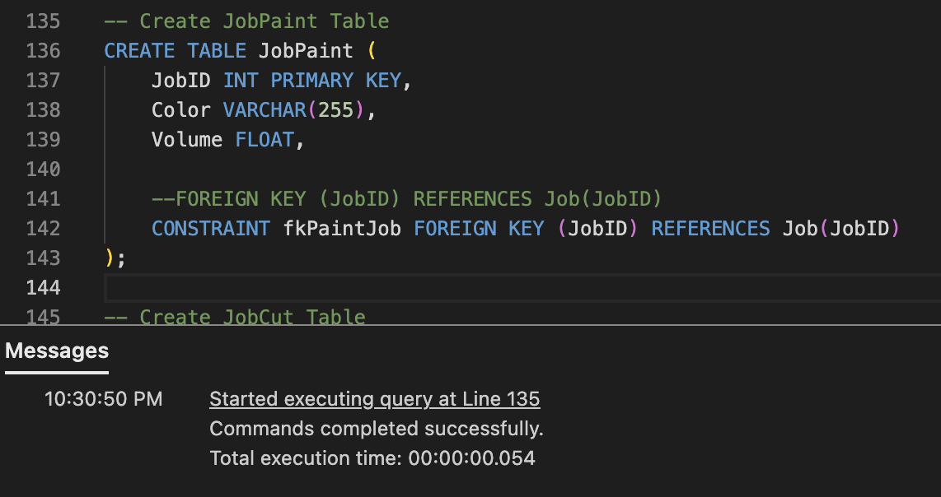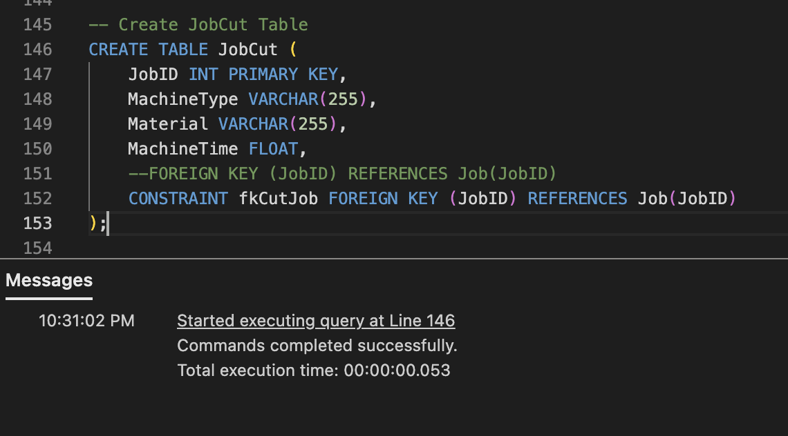

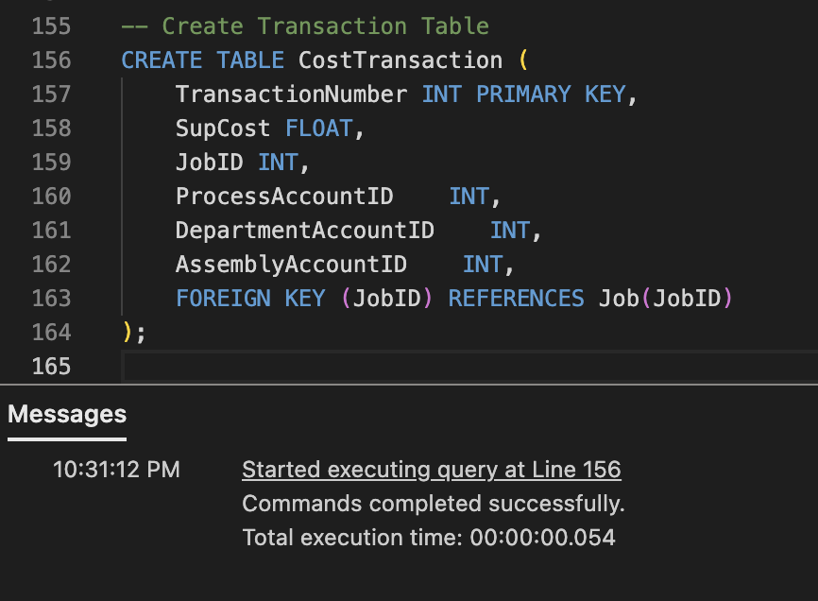

Task 5: queries

5.1: Stored Proc

Query1

SET ANSI_NULLS ON

GO

SET QUOTED_IDENTIFIER ON

GO

-- Create a stored procedure to insert a new customer

-- NewCustomer 'Gabe', 'home', 11

CREATE PROCEDURE [dbo].[usp_InsertCustomer]

@CustomerName VARCHAR(255),

@Address VARCHAR(255),

@Category INT

AS

BEGIN

-- Check if the customer already exists

IF @Category >= 1 AND @Category <= 10

BEGIN

IF NOT EXISTS (SELECT 1 FROM Customer WHERE CustomerName = @CustomerName)

BEGIN

-- Insert the new customer

INSERT INTO Customer (CustomerName, [Address], Category)

VALUES (@CustomerName, @Address, @Category);

END

END

END;

GO

Query2

SET ANSI_NULLS ON

GO

SET QUOTED_IDENTIFIER ON

GO

-- Create a stored procedure to insert a new department

-- usp_CreateNewDepartment 1, 'Datatatatatatatta'

CREATE PROCEDURE [dbo].[usp_CreateNewDepartment]

(

@DepartmentNumber INT,

@DepartmentData VARCHAR(255)

)

AS

BEGIN

-- Check if the department number already exists

IF NOT EXISTS (SELECT 1 FROM Department WHERE DepartmentNumber = @DepartmentNumber)

BEGIN

-- Insert the new department

INSERT INTO Department (

DepartmentNumber,

DepartmentData)

VALUES (

@DepartmentNumber,

@DepartmentData);

END

END;

GO

Query3

SET ANSI_NULLS ON

GO

SET QUOTED_IDENTIFIER ON

GO

-- Create a stored procedure to insert a new process with type information

-- usp_CreateNewDepartment 1, 'Datatatatatatatta'

-- InsertProcessWithType 3, 1, 1, 2, 'THE FIT'

CREATE PROCEDURE [dbo].[usp_CreateProcess]

(

@ProcessID INT,

@ProcessTypeID INT,

@DepartmentNumber INT,

@ProcessInfoID INT,

@Attr1 VARCHAR(255),

@Attr2 VARCHAR(255) = NULL

)

AS

BEGIN

IF EXISTS (

SELECT 1 FROM Department

WHERE @DepartmentNumber = DepartmentNumber

)

BEGIN

IF NOT EXISTS (SELECT 1 FROM Process WHERE ProcessID = @ProcessID)

BEGIN

-- insert process info

INSERT INTO ProcessInfo(ProcessInfoID, Attr1, Attr2)

VALUES (@ProcessInfoID, @Attr1, @Attr2)

-- Insert into Process table

INSERT INTO Process (ProcessID, ProcessTypeID, DepartmentNumber, ProcessInfoID)

VALUES (@ProcessID, @ProcessTypeID, @DepartmentNumber,@ProcessInfoID);

PRINT 'Process with type information inserted successfully.';

END

END

END;

GO

Query4

SET ANSI_NULLS ON

GO

SET QUOTED_IDENTIFIER ON

GO

-- usp_InsertCustomer 'Gabe', 'Norman', '1'

-- usp_CreateNewDepartment 1, 'Datatatatatatatta'

-- usp_CreateProcess 2, 1, 1, 2, 'Another type'

-- usp_CreateAssembly 1, '2023-11-12', 'Details', 'Gabe', 2

CREATE PROCEDURE [dbo].[usp_CreateAssembly]

(

@AssemblyID INT,

@DateOrdered DATE,

@AssemblyDetails VARCHAR(255),

@CustomerName VARCHAR(255),

@ProcessID INT

)

AS

BEGIN

IF EXISTS (SELECT 1 FROM Customer WHERE CustomerName = @CustomerName)

BEGIN

IF NOT EXISTS (SELECT 1 FROM [Assembly] WHERE [AssemblyID] = @AssemblyID)

BEGIN

INSERT INTO [Assembly] (AssemblyID, CustomerName, DateOrdered, AssemblyDetails)

VALUES (@AssemblyID, @CustomerName, @DateOrdered, @AssemblyDetails)

INSERT INTO [AssemblyXREF] (AssemblyID, ProcessID)

VALUES(@AssemblyID, @ProcessID)

END

ELSE

BEGIN

INSERT INTO [AssemblyXREF] (AssemblyID, ProcessID)

VALUES(@AssemblyID, @ProcessID)

END

END

END;

GO

Query5

SET ANSI_NULLS ON

GO

SET QUOTED_IDENTIFIER ON

GO

-- Create a stored procedure to insert a new process with type information

/*

EXEC usp_InsertCustomer 'Gabe', 'Norman', '1'

EXEC usp_CreateNewDepartment 1, 'Datatatatatatatta'

EXEC usp_CreateProcess 3, 1, 1, 2, 'Another type'

EXEC usp_CreateAssembly 2, '2023-11-12', 'Details', 'Gabe', 3

-- Associate with a assembly

EXEC [dbo].[usp_CreateAccount] 1, 2, '2023-11-12', 0, 1

-- Associate with a department

EXEC [dbo].[usp_CreateAccount] 2, 1, '2023-11-12', 0, 2

-- Associate with a process

EXEC [dbo].[usp_CreateAccount] 3, 3, '2023-11-12', 0, 3

*/

--

--

CREATE PROCEDURE [dbo].[usp_CreateAccount]

(

@AccountNumber INT,

@AssociationID INT,

@DateCreated DATE,

--@Details FLOAT,

@AccountTypeID INT

)

AS

BEGIN

IF EXISTS (

SELECT 1 FROM AccountType

WHERE @AccountTypeID = AccountTypeID

)

BEGIN

IF( @AccountTypeID = 1) -- Assembly Account type

BEGIN

IF NOT EXISTS (SELECT 1 FROM Account WHERE AccountNumber = @AccountNumber)

BEGIN

INSERT INTO Account(AccountNumber, DateCreated, Details, AccountTypeID)

VALUES (@AccountNumber, @DateCreated, 0, @AccountTypeID)

UPDATE [dbo].[Assembly]

SET AccountNumber = @AccountNumber

WHERE [AssemblyID] = @AssociationID

END

ELSE

BEGIN

UPDATE [dbo].[Assembly]

SET AccountNumber = @AccountNumber

WHERE [AssemblyID] = @AssociationID

END

END

IF( @AccountTypeID = 2) -- Department

BEGIN

IF NOT EXISTS (SELECT 1 FROM Account WHERE AccountNumber = @AccountNumber)

BEGIN

INSERT INTO Account(AccountNumber, DateCreated, Details, AccountTypeID)

VALUES (@AccountNumber, @DateCreated, 0, @AccountTypeID)

UPDATE Department

SET AccountNumber = @AccountNumber

WHERE DepartmentNumber = @AssociationID

END

BEGIN

UPDATE Department

SET AccountNumber = @AccountNumber

WHERE DepartmentNumber = @AssociationID

END

END

IF( @AccountTypeID = 3) -- Process

BEGIN

IF NOT EXISTS (SELECT 1 FROM Account WHERE AccountNumber = @AccountNumber)

BEGIN

INSERT INTO Account(AccountNumber, DateCreated, Details, AccountTypeID)

VALUES (@AccountNumber, @DateCreated, 0, @AccountTypeID)

UPDATE Process

SET AccountNumber = @AccountNumber

WHERE ProcessID = @AssociationID

END

BEGIN

UPDATE Process

SET AccountNumber = @AccountNumber

WHERE ProcessID = @AssociationID

END

END

END

END;

GO

Query6

SET ANSI_NULLS ON

GO

SET QUOTED_IDENTIFIER ON

GO

-- Create a stored procedure to insert a new process with type information

/*

EXEC usp_InsertCustomer 'Gabe', 'Norman', '1'

EXEC usp_CreateNewDepartment 1, 'Datatatatatatatta'

EXEC usp_CreateProcess 3, 1, 1, 2, 'Another type'

EXEC usp_CreateAssembly 2, '2023-11-12', 'Details', 'Gabe', 3

-- creates fit job

EXEC [dbo].[usp_CreateJob] 1, 2, 3, '2023-11-12'

-- creates paint job

EXEC [dbo].[usp_CreateJob] 2, 2, 3, '2023-11-12'

-- creates cut job

EXEC [dbo].[usp_CreateJob] 3, 2, 3, '2023-11-12'

*/

--

--

CREATE PROCEDURE [dbo].[usp_CreateJob]

(

@JobID INT,

@AssemblyID INT,

@ProcessID INT,

@JobDateStart DATE

)

AS

BEGIN

IF NOT EXISTS (SELECT 1 FROM Job WHERE JobID = @JobID)

BEGIN

IF EXISTS (SELECT 1 FROM Process WHERE ProcessID = @ProcessID )

BEGIN

IF EXISTS (SELECT 1 FROM [Assembly] WHERE AssemblyID = @AssemblyID )

BEGIN

INSERT INTO Job(JobID, AssemblyID, ProcessID, JobDateStart)

VALUES (@JobID, @AssemblyID, @ProcessID, @JobDateStart)

PRINT 'INSERTED JOB'

END

ELSE

PRINT 'Assembly Doesnt Exist'

END

ELSE

PRINT 'Process Doesnt Exist'

END

ELSE

BEGIN

IF EXISTS (SELECT 1 FROM Process WHERE @ProcessID = ProcessID)

BEGIN

IF EXISTS (SELECT 1 FROM [Assembly] WHERE @AssemblyID = AssemblyID)

BEGIN

UPDATE [dbo].[Job]

SET JobID = @JobID,

AssemblyID = @AssemblyID,

ProcessID = @ProcessID,

JobDateStart = @JobDateStart

WHERE [JobID] = @JobID

END

ELSE

PRINT 'Assembly Doesnt Exist'

END

ELSE

PRINT 'Process Doesnt Exist'

END

END;

GO

Query7

SET ANSI_NULLS ON

GO

SET QUOTED_IDENTIFIER ON

GO

-- Create a stored procedure to insert a new process with type information

/*

EXEC usp_InsertCustomer 'Gabe', 'Norman', '1'

EXEC usp_CreateNewDepartment 1, 'Datatatatatatatta'

EXEC usp_CreateProcess 3, 1, 1, 2, 'Another type'

EXEC usp_CreateAssembly 2, '2023-11-12', 'Details', 'Gabe', 3

-- creates fit job

EXEC [dbo].[usp_CompleteJob] 1, 1 , '2023-11-12', 0.69

-- creates paint job

EXEC [dbo].[usp_CompleteJob] 2, 2, '2023-11-12', 0.69, 'BLUE', 100

-- creates cut job

EXEC [dbo].[usp_CompleteJob] 3, 3, '2023-11-12', 0.69, null, null, 'CUTTER2000', 12, 'Titanium'

*/

--

--

CREATE PROCEDURE [dbo].[usp_CompleteJob]

(

@JobID INT,

@JobTypeID INT,

@JobDateEnd DATE,

@LaborTime FLOAT,

@Color VARCHAR(255) = NULL,

@Volume FLOAT = NULL,

@MachineType VARCHAR(255)= NULL,

@MachineTime FLOAT = NULL,

@Material VARCHAR(255) = NULL

)

AS

BEGIN

IF EXISTS (SELECT 1 FROM Job WHERE JobID = @JobID)

BEGIN

UPDATE Job

SET JobID = @JobID,

JobDateEnd = @JobDateEnd,

JobTypeID = @JobTypeID,

LaborTime = @LaborTime

WHERE JobID = @JobID

PRINT 'UPDATE JOB'

IF(@JobTypeID = 1)

BEGIN

PRINT 'Inserting job fit type'

INSERT INTO JobFit(JobID)

VALUES (@JobID)

END

IF(@JobTypeID = 2)

BEGIN

PRINT 'Inserting job paint type'

INSERT INTO JobPaint(JobID, Color, Volume)

VALUES (@JobID, @Color, @Volume)

END

IF(@JobTypeID = 3)

BEGIN

PRINT 'Inserting job cut type'

INSERT INTO JobCut(JobID, MachineType, MachineTime, Material)

VALUES (@JobID, @MachineType, @MachineTime, @Material)

END

END

ELSE

PRINT('No Job Exists for that number')

END;

GO

Query8

SET ANSI_NULLS ON

GO

SET QUOTED_IDENTIFIER ON

GO

-- Create a stored procedure to insert a new process with type information

/*

EXEC usp_InsertCustomer 'Gabe', 'Norman', '1'

EXEC usp_CreateNewDepartment 1, 'Datatatatatatatta'

EXEC usp_CreateProcess 3, 1, 1, 2, 'Another type'

EXEC usp_CreateAssembly 2, '2023-11-12', 'Details', 'Gabe', 3

-- Create accounts

EXEC [dbo].[usp_CreateAccount] 1, 2, '2023-11-12', 0, 1

EXEC [dbo].[usp_CreateAccount] 2, 1, '2023-11-12', 0, 2

EXEC [dbo].[usp_CreateAccount] 3, 3, '2023-11-12', 0, 3

EXEC [dbo].[usp_CreateJob] 1, 2, 3, '2023-11-12'

EXEC [dbo].[usp_CreateJob] 2, 2, 3, '2023-11-12'

EXEC [dbo].[usp_CreateJob] 3, 2, 3, '2023-11-12'

EXEC [dbo].[usp_CreateTransaction] 11, 9, 1

*/

--

--

CREATE PROCEDURE [dbo].[usp_CreateTransaction]

(

@TransactionNumber INT,

@JobID INT,

@SupCost FLOAT

)

AS

BEGIN

INSERT INTO CostTransaction (TransactionNumber,JobID, SupCost)

VALUES(@TransactionNumber, @JobID, @SupCost)

DECLARE @ProcessAccountNumber INT;

DECLARE @DepartmentAccountNumber INT;

DECLARE @AssemblyAccountNumber INT;

SELECT DISTINCT @ProcessAccountNumber = p.AccountNumber

FROM Process p

INNER JOIN Job j

ON p.ProcessID = j.ProcessID

INNER JOIN Account a

ON p.AccountNumber = a.AccountNumber

WHERE 1 = j.JobID

SELECT DISTINCT @DepartmentAccountNumber = d.AccountNumber

FROM Process p

INNER JOIN Job j

ON p.ProcessID = j.ProcessID

INNER JOIN Department d

ON d.DepartmentNumber = d.DepartmentNumber

WHERE 1 = j.JobID

SELECT DISTINCT @AssemblyAccountNumber = a.AccountNumber

FROM Process p

INNER JOIN Job j

ON p.ProcessID = j.ProcessID

INNER JOIN AssemblyXREF x

ON x.ProcessID = p.ProcessID

INNER JOIN [Assembly] a

ON x.AssemblyID = a.AssemblyID

WHERE 1 = j.JobID

PRINT @ProcessAccountNumber

PRINT @DepartmentAccountNumber

PRINT @AssemblyAccountNumber

UPDATE Account

SET Details += @SupCost

WHERE AccountNumber = @ProcessAccountNumber

UPDATE Account

SET Details += @SupCost

WHERE AccountNumber = @DepartmentAccountNumber

UPDATE Account

SET Details += @SupCost

WHERE AccountNumber = @AssemblyAccountNumber

END;

GO

Query9

SET ANSI_NULLS ON

GO

SET QUOTED_IDENTIFIER ON

GO

-- usp_InsertCustomer 'Gabe', 'Norman', '1'

-- usp_CreateNewDepartment 1, 'Datatatatatatatta'

-- usp_CreateProcess 2, 1, 1, 2, 'Another type'

-- usp_CreateAssembly 1, '2023-11-12', 'Details', 'Gabe', 2

CREATE PROCEDURE [dbo].[usp_GetAssemblyCost]

(

@AssemblyID INT

)

AS

BEGIN

SELECT ac.AccountNumber,

a.AssemblyID,

ac.Details

FROM Account ac

INNER JOIN [Assembly] a

ON a.AccountNumber = ac.AccountNumber

Where a.AssemblyID = @AssemblyID

END;

GO

Query10

SET ANSI_NULLS ON

GO

SET QUOTED_IDENTIFIER ON

GO

-- Create a stored procedure to insert a new process with type information

/*

EXEC usp_InsertCustomer 'Gabe', 'Norman', '1'

EXEC usp_CreateNewDepartment 1, 'Datatatatatatatta'

EXEC usp_CreateProcess 3, 1, 1, 2, 'Another type'

EXEC usp_CreateAssembly 2, '2023-11-12', 'Details', 'Gabe', 3

-- creates fit job

EXEC [dbo].[usp_CreateJob] 1, 2, 3, '2023-11-12'

-- creates paint job

EXEC [dbo].[usp_CreateJob] 2, 2, 3, '2023-11-12'

-- creates cut job

EXEC [dbo].[usp_CreateJob] 4, 2, 3, '2023-11-12'

EXEC [dbo].[usp_CompleteJob] 1, 1 , '2023-11-12', 0.69

EXEC [dbo].[usp_CompleteJob] 2, 2 , '2023-11-12', 10

EXEC [dbo].[usp_CompleteJob] 4, 3 , '2024-11-12', 200

EXEC [dbo].[usp_GetDepartmentTime] 1, '2023-12-12'

*/

--

--

CREATE PROCEDURE [dbo].[usp_GetDepartmentTime]

(

@DepartmentNumber INT,

@StartDate DATE = NULL,

@EndDate DATE = NULL

)

AS

BEGIN

SELECT SUM(j.LaborTime)

FROM Department d

INNER JOIN Process p

ON d.DepartmentNumber = p.DepartmentNumber

INNER JOIN Job j

ON j.ProcessID = p.ProcessID

WHERE (j.JobDateEnd >= @StartDate OR @StartDate IS NULL)

AND (j.JobDateEnd <= @EndDate OR @EndDate IS NULL)

AND d.DepartmentNumber = @DepartmentNumber

END;

GO

Query11

SET ANSI_NULLS ON

GO

SET QUOTED_IDENTIFIER ON

GO

-- [dbo].[usp_GetCompletedProcesses] 1

CREATE PROCEDURE [dbo].[usp_GetCompletedProcesses]

(

@AssemblyID INT

)

AS

BEGIN

SELECT DISTINCT p.ProcessID,

p.DepartmentNumber,

j.JobID,

j.JobDateEnd

FROM [Assembly] a

INNER JOIN [AssemblyXREF] x

ON a.AssemblyID = x.AssemblyID

INNER JOIN Process p

ON p.ProcessID = x.ProcessID

INNER JOIN Job j

ON j.ProcessID = p.ProcessID

WHERE j.JobDateEnd IS NOT NULL

AND a.AssemblyID = @AssemblyID

ORDER BY j.JobDateEnd ASC

END;

GO

Query12

SET ANSI_NULLS ON

GO

SET QUOTED_IDENTIFIER ON

GO

CREATE PROCEDURE [dbo].[usp_GetCustomer]

(

@CategoryMin INT = NULL,

@CategoryMax INT = NULL

)

AS

BEGIN

SELECT CustomerName,

[Address],

Category

FROM Customer

Where (Category >= @CategoryMin OR @CategoryMin IS NULL) AND

(Category <= @CategoryMax OR @CategoryMax IS NULL)

END;

GO

Query13

SET ANSI_NULLS ON

GO

SET QUOTED_IDENTIFIER ON

GO

CREATE PROCEDURE [dbo].[usp_DeleteJobs]

(

@JobIDMin INT,

@JobIDMax INT

)

AS

BEGIN

DELETE FROM JobCut

WHERE (JobID >= @JobIDMin)

AND (JobID <= @JobIDMax)

DELETE FROM CostTransaction

WHERE (JobID >= @JobIDMin)

AND (JobID <= @JobIDMax)

DELETE FROM Job

WHERE (JobID >= @JobIDMin)

AND (JobID <= @JobIDMax)

AND JobTypeID = 3

END;

GO

Query14

SET ANSI_NULLS ON

GO

SET QUOTED_IDENTIFIER ON

GO

CREATE PROCEDURE [dbo].[usp_ChangeColor]

(

@JobID INT,

@Color VARCHAR(255)

)

AS

BEGIN

IF EXISTS(SELECT 1 FROM JobPaint WHERE JobID = @JobID)

BEGIN

UPDATE JobPaint

SET Color = @Color

WHERE JobID = @JobID

END

ELSE

BEGIN

PRINT('Selected Job is not of Job:Paint type')

END

END;

GO

Queries 15 and 16 are equivaluent to Queries 1 and 12 respectivly.

5.2: execution

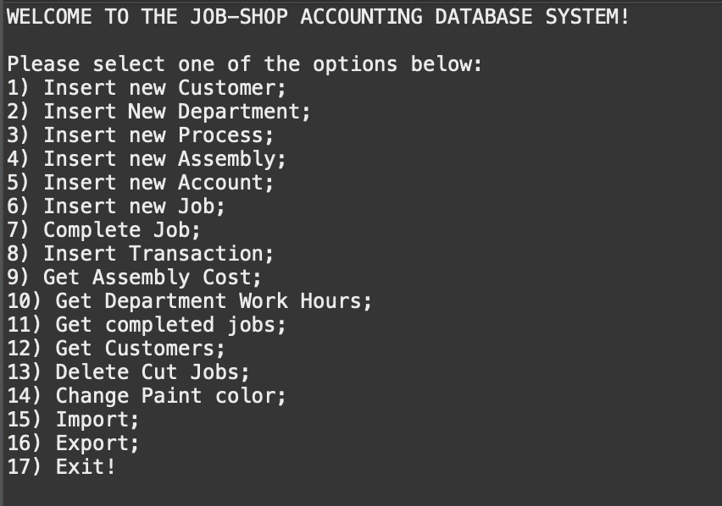

Task 6: JavaExecution

Task 6.1: create customers

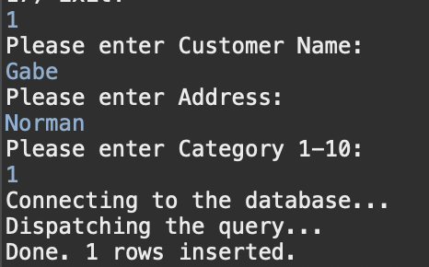

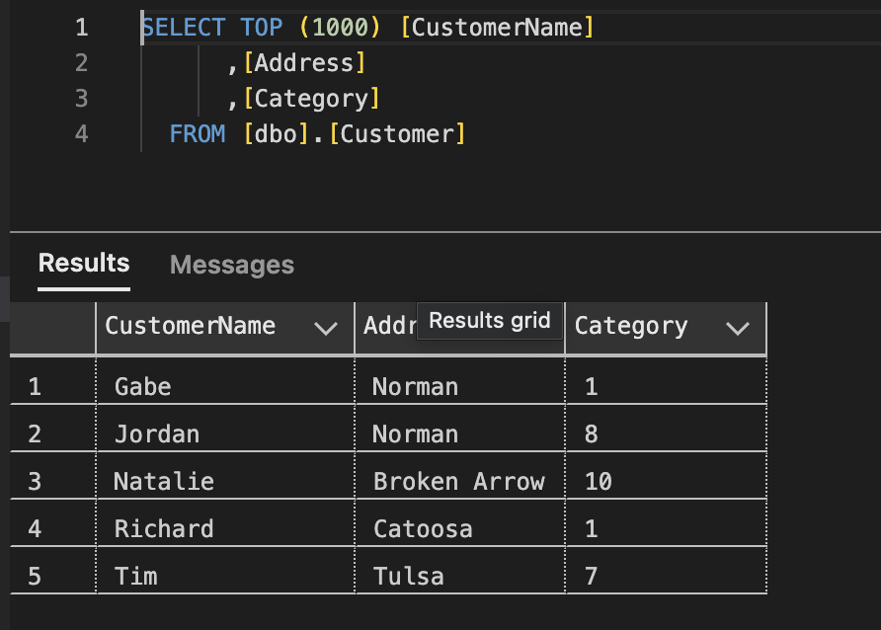

Task 6.2: create departments

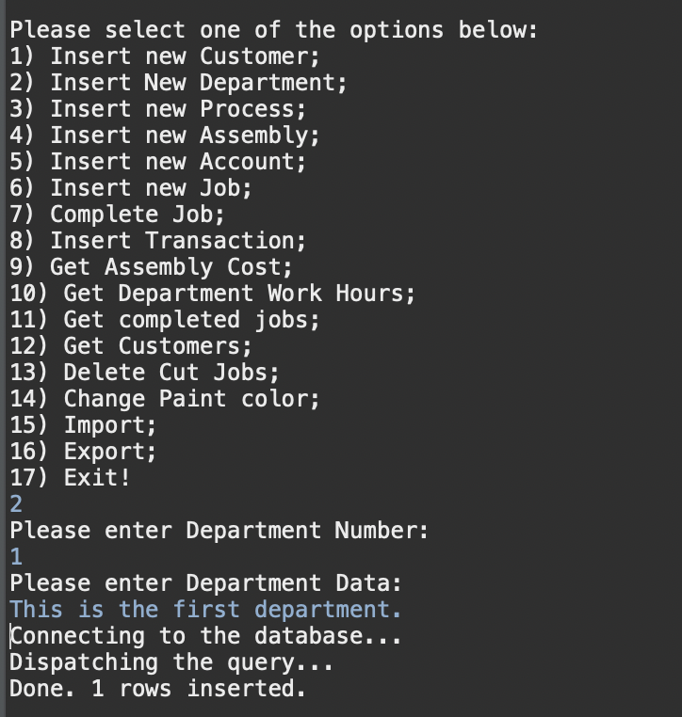

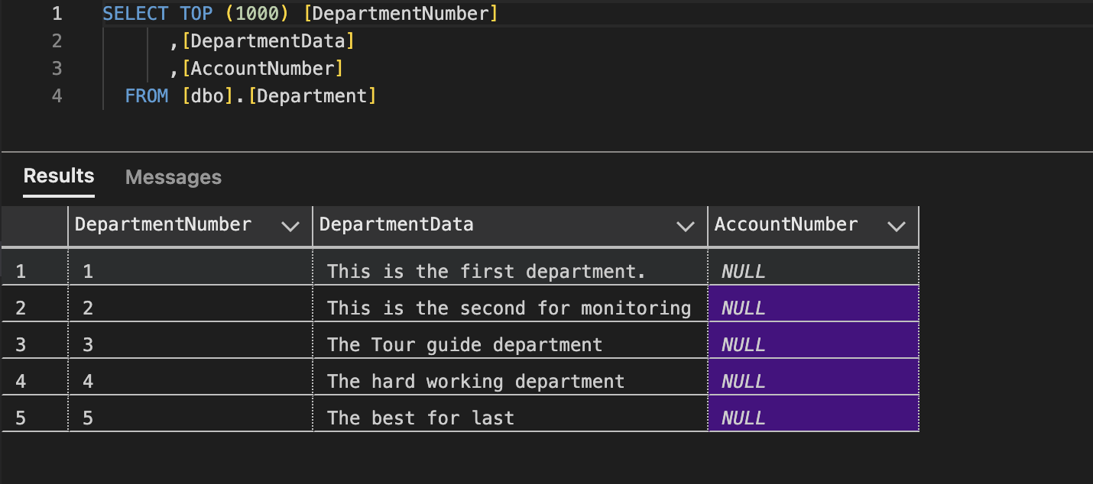

Task 6.3: create processes

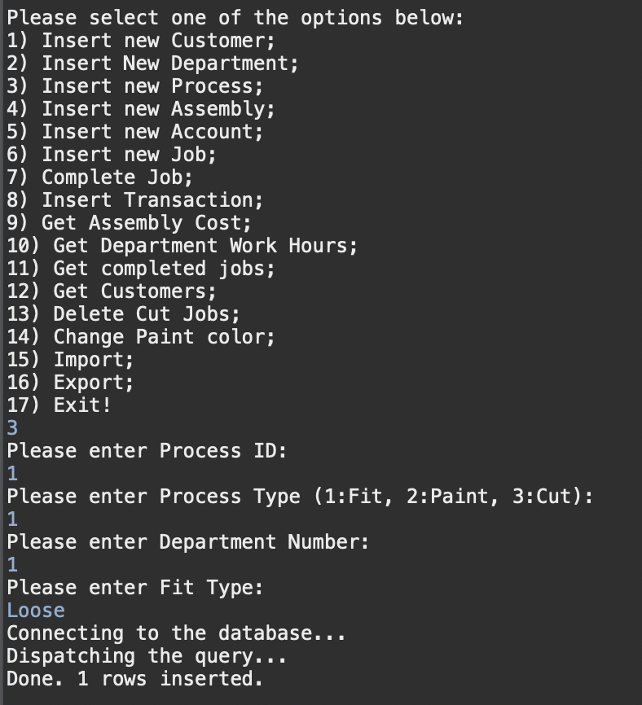

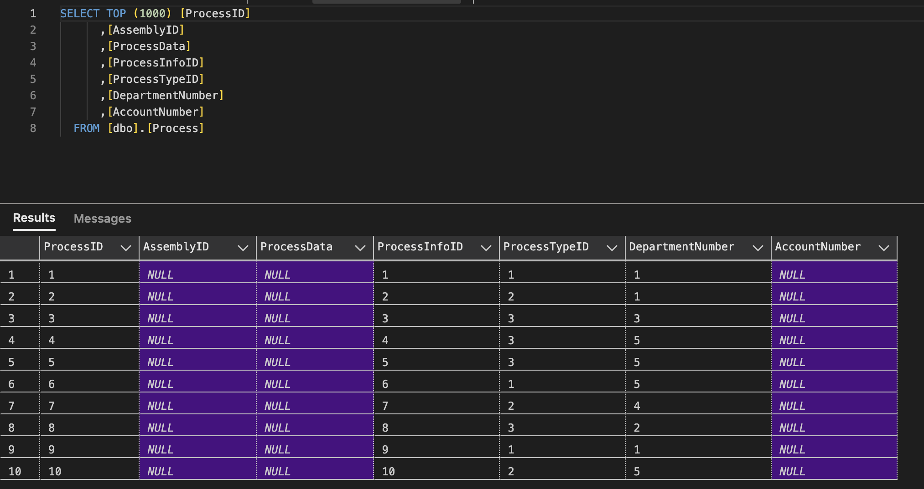

Task 6.4: create assemblies

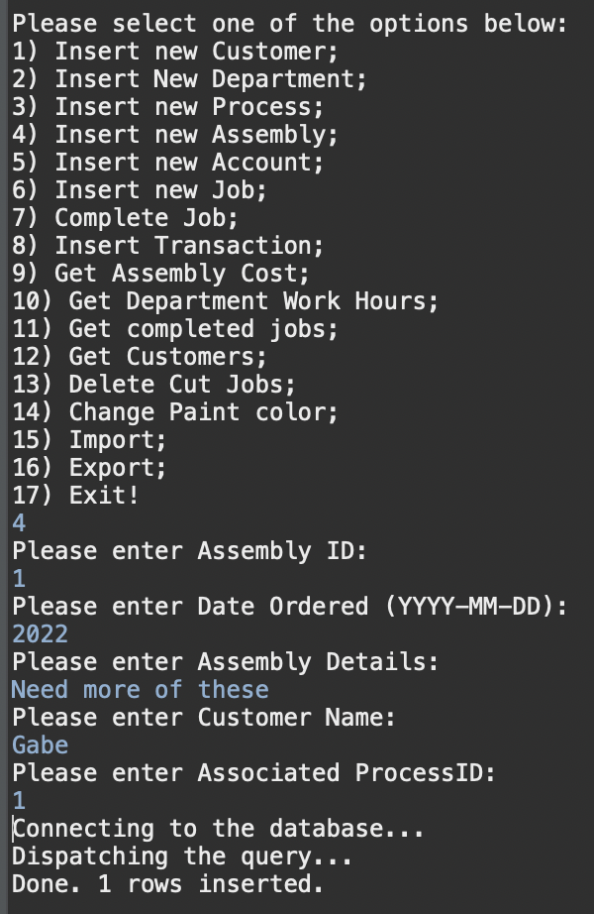

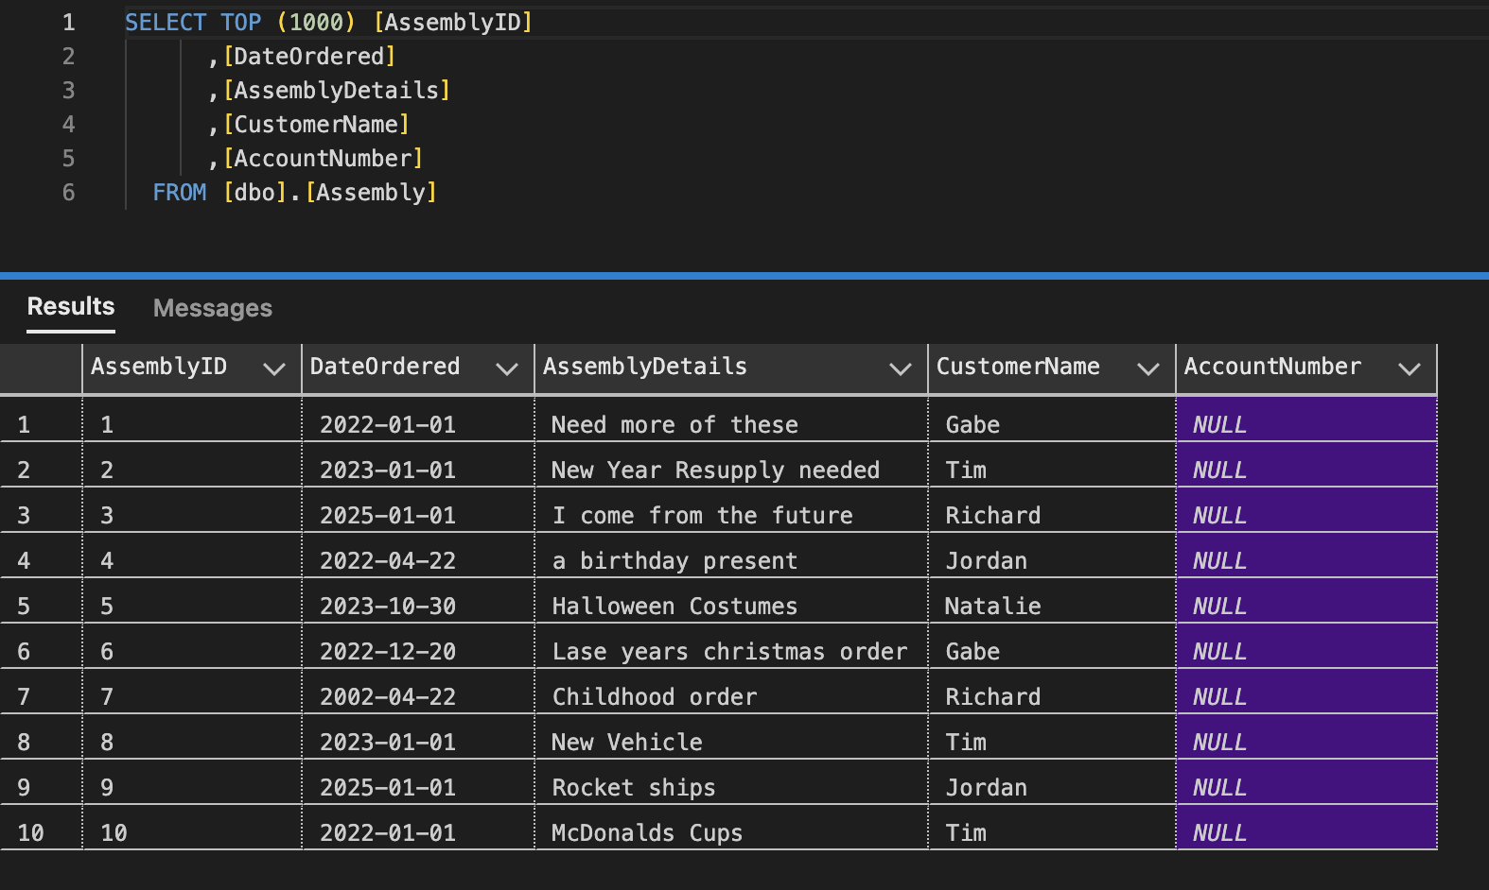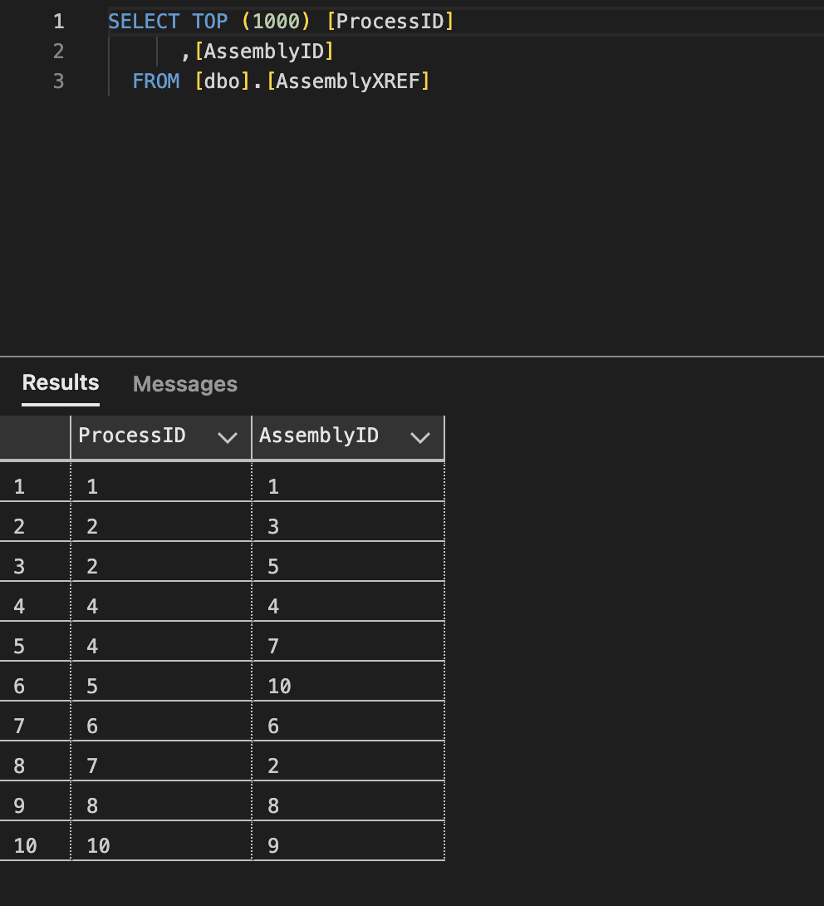

Task 6.5: Create accounts

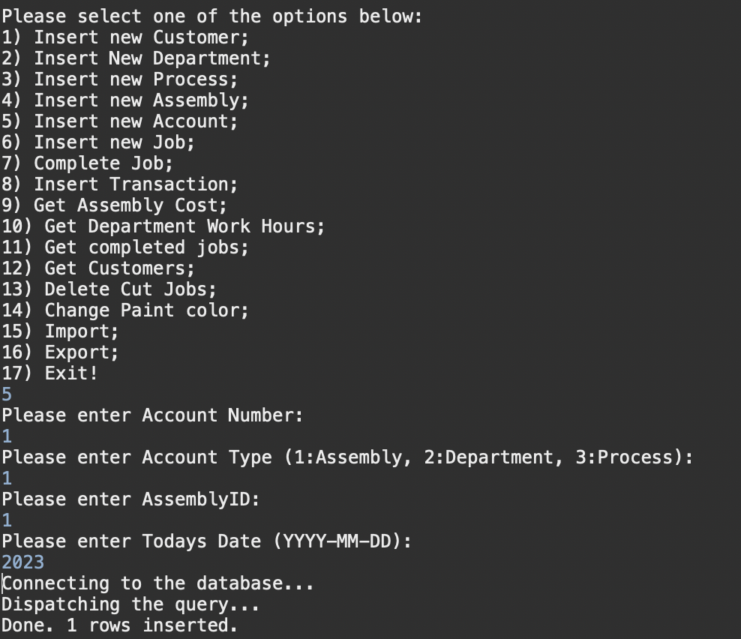

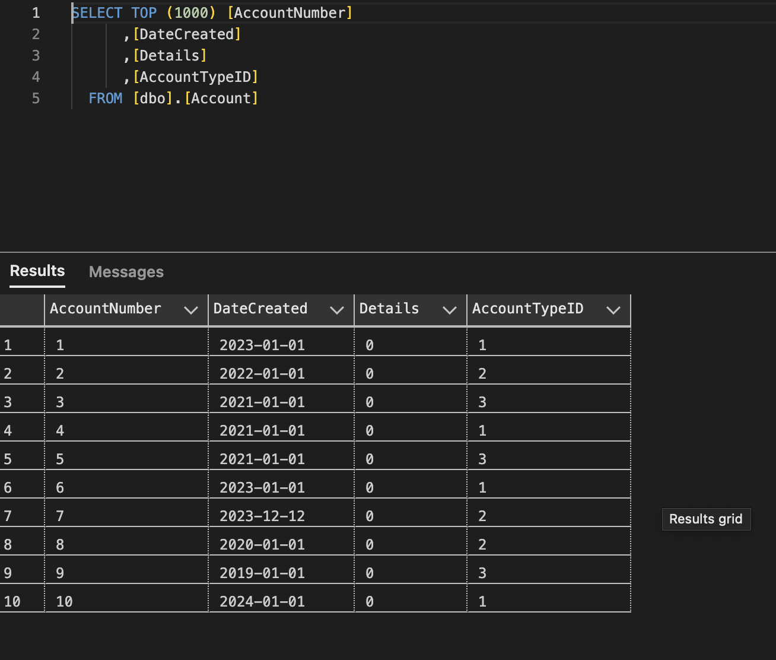

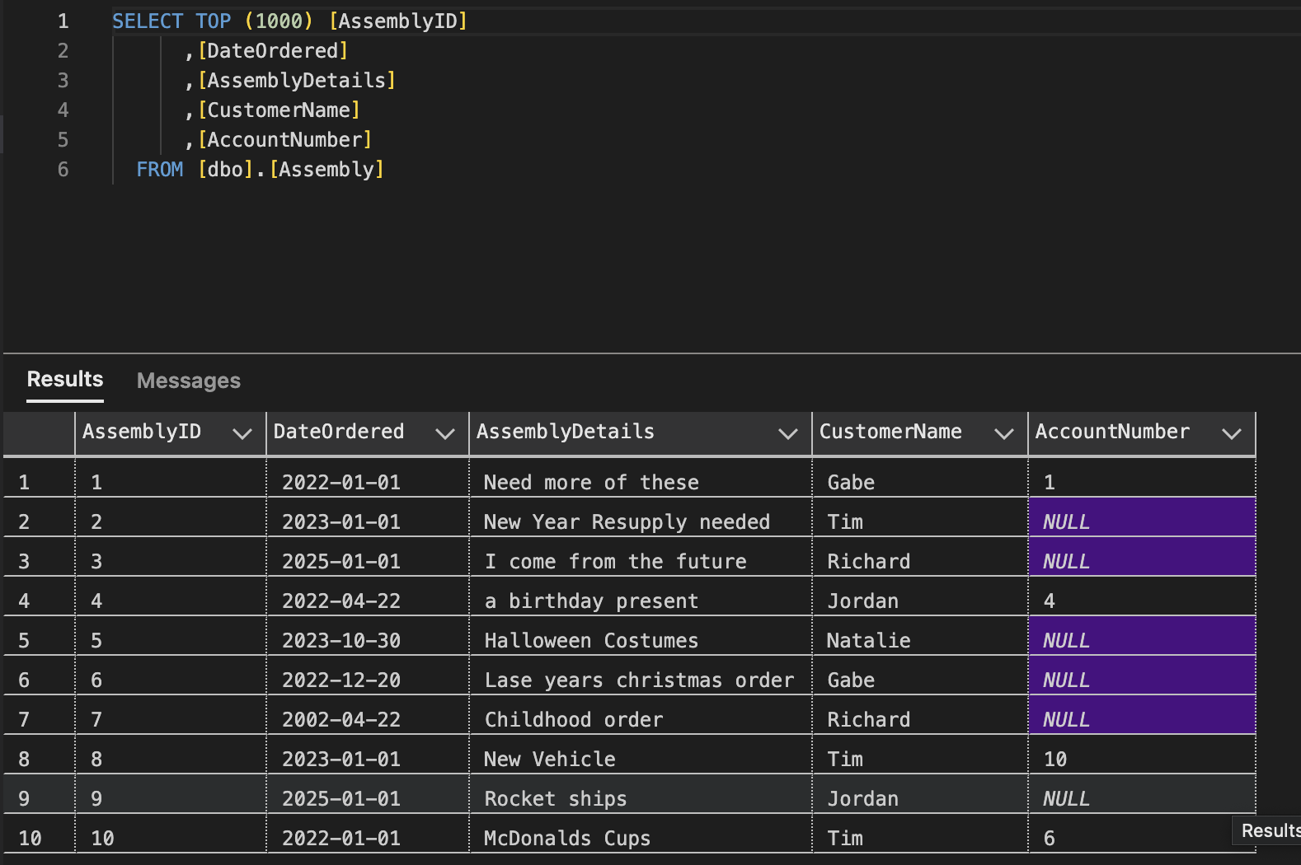

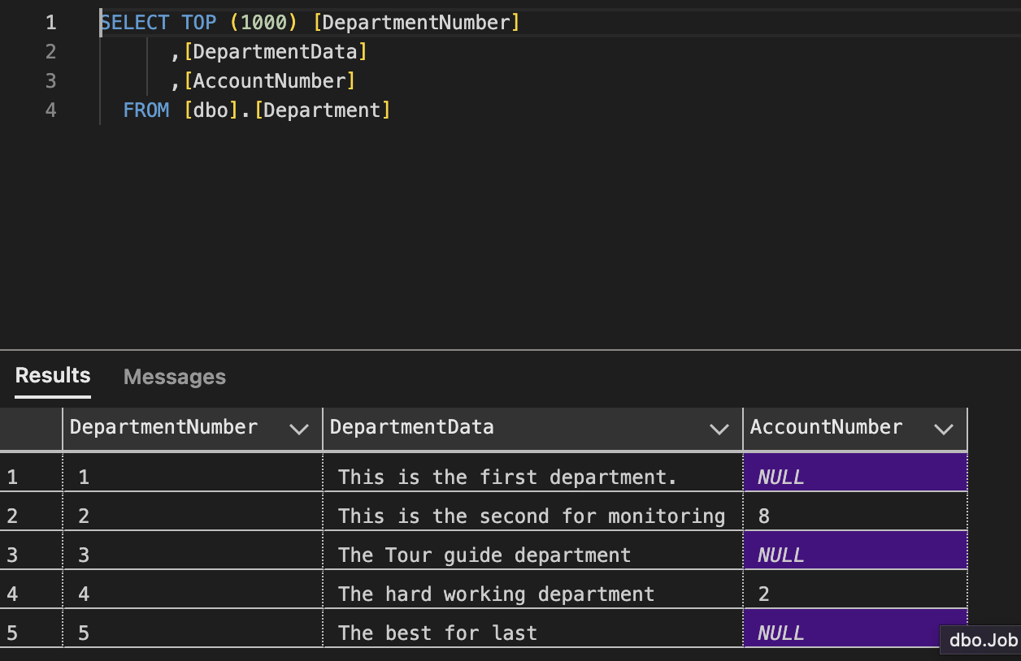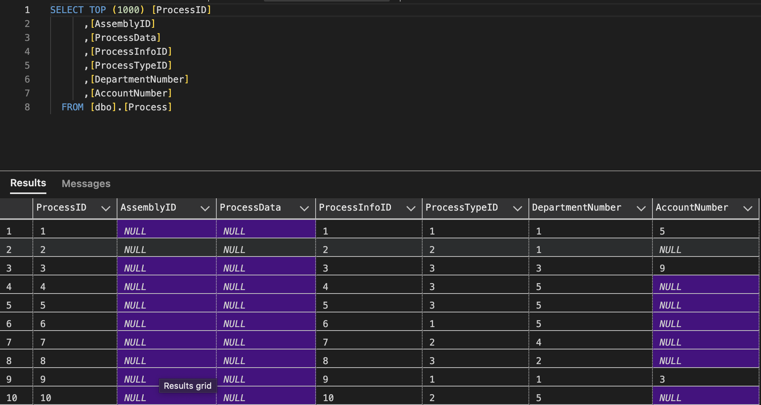

Task 6.6: Create Jobs

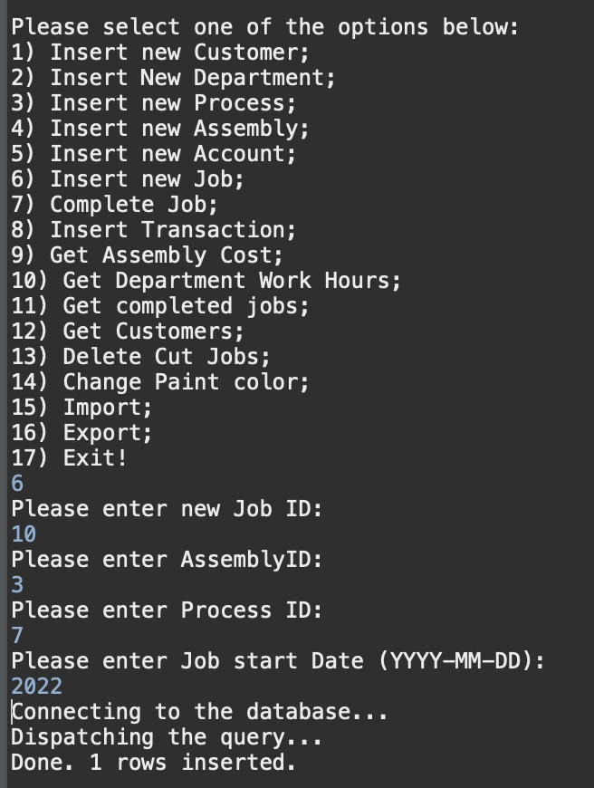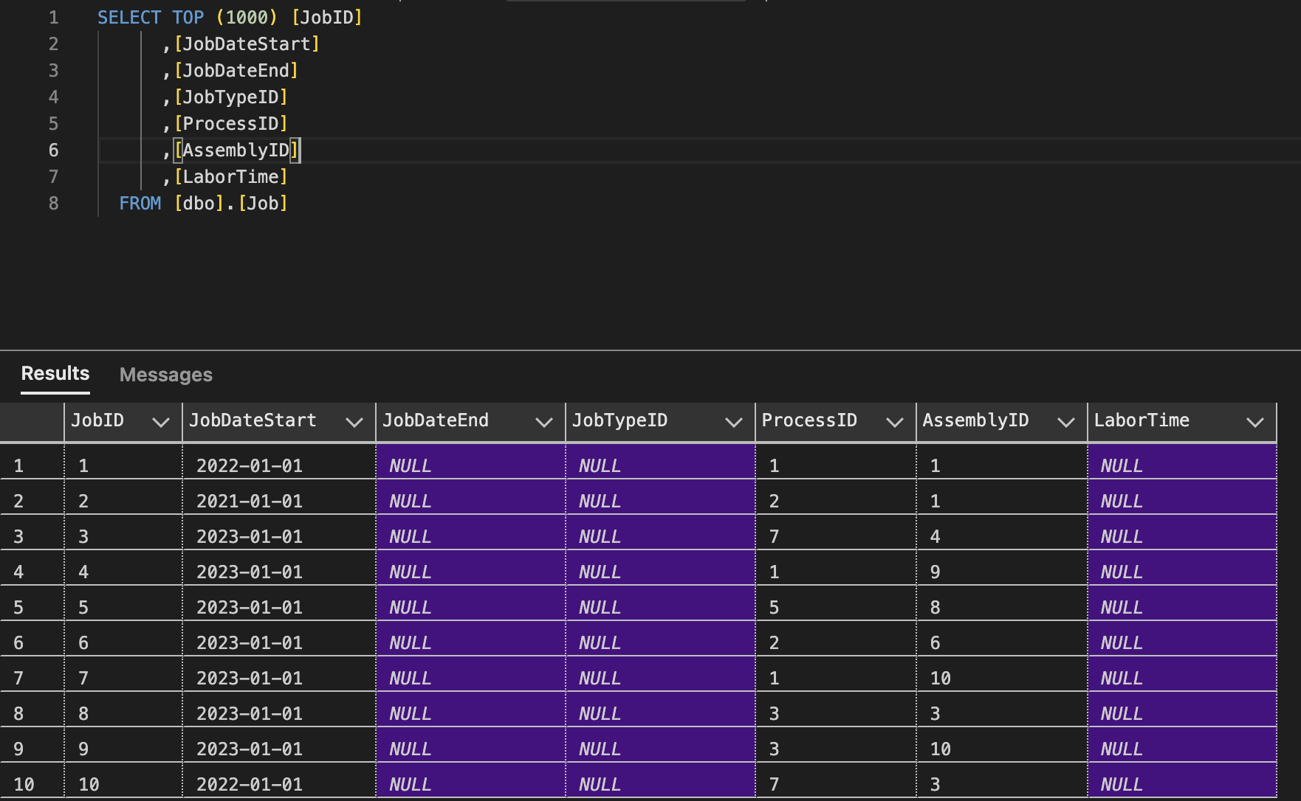

Task 6.7: Complete Jobs

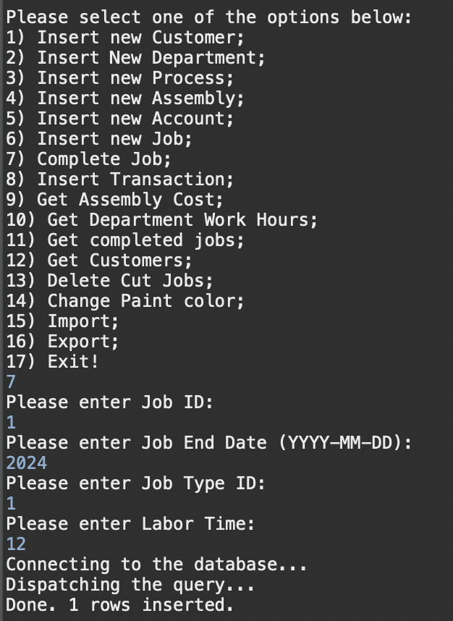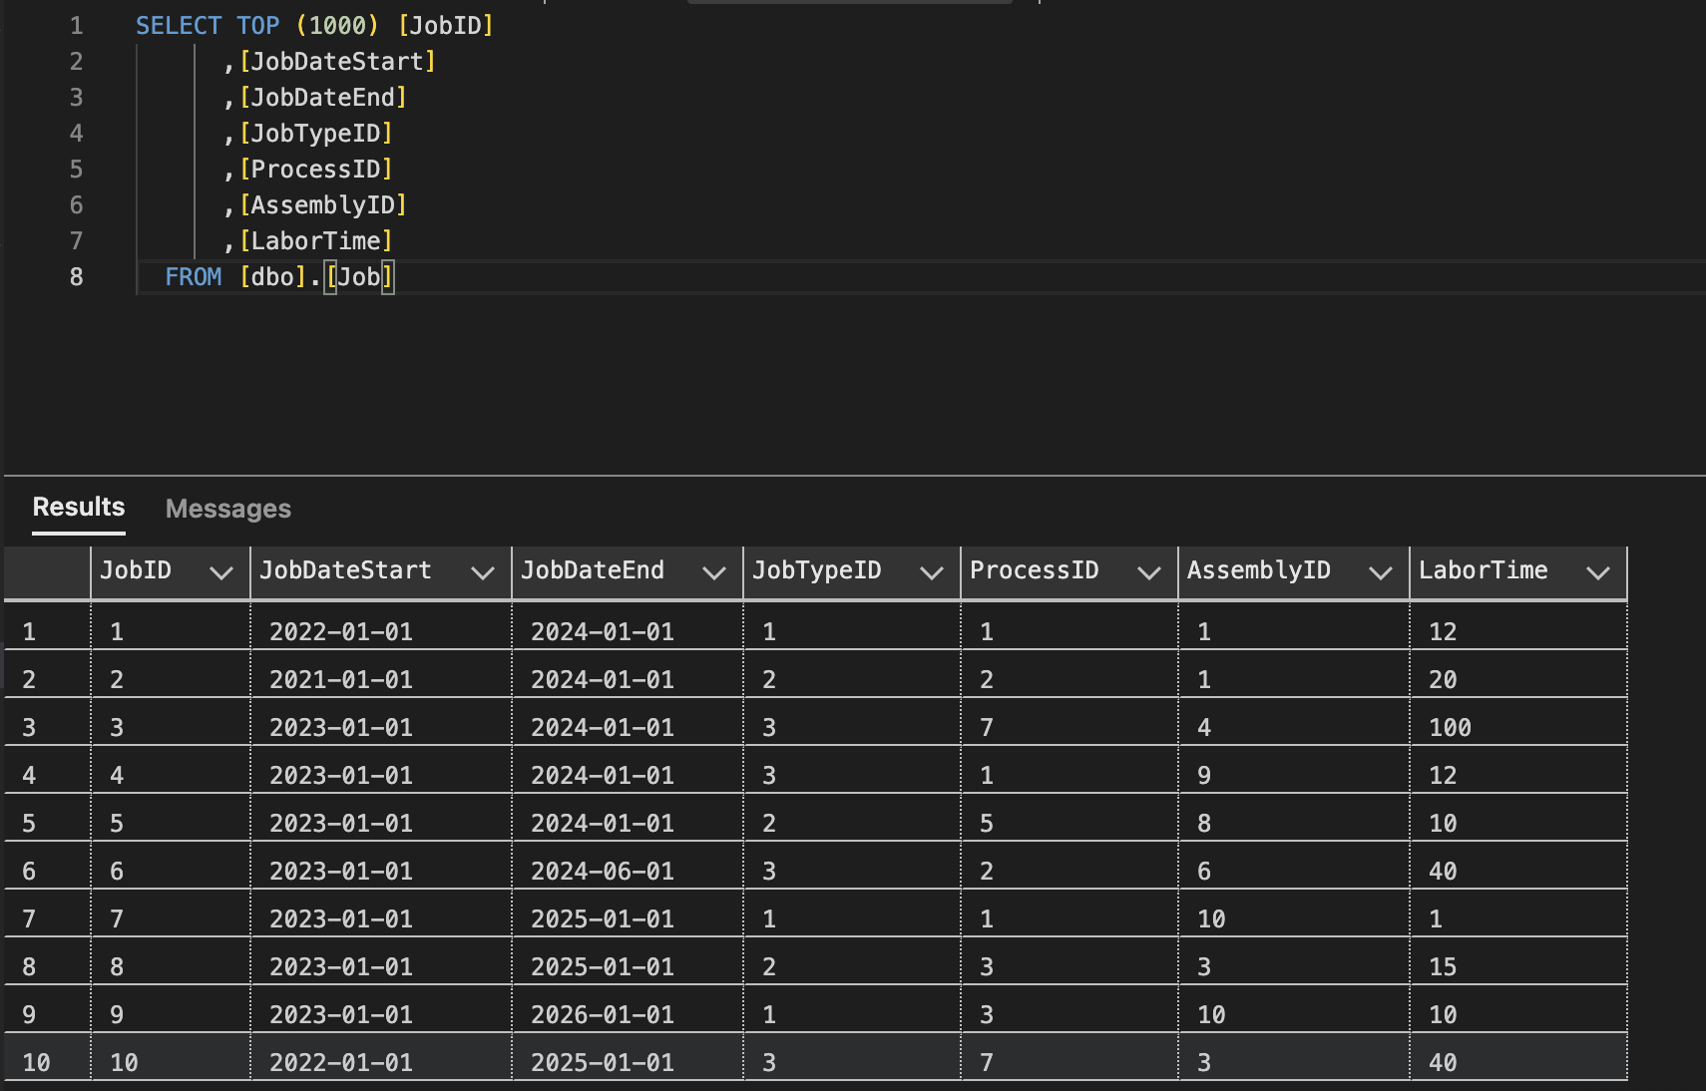

Task 6.8: insert transaction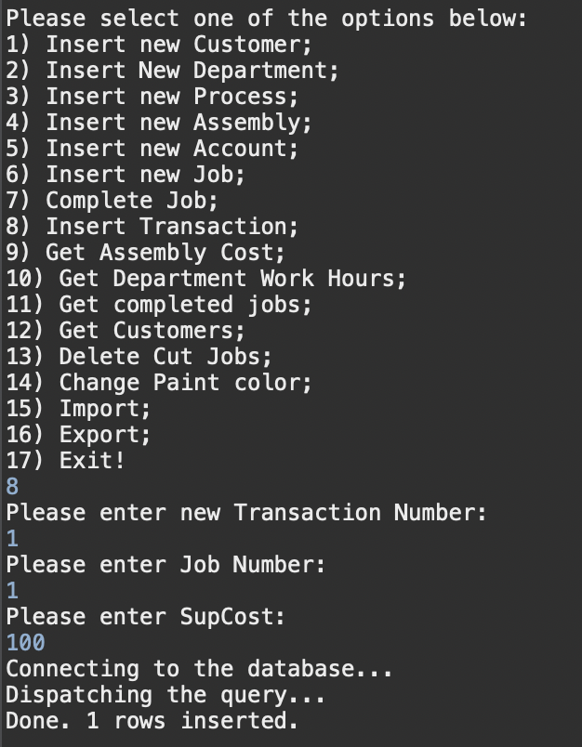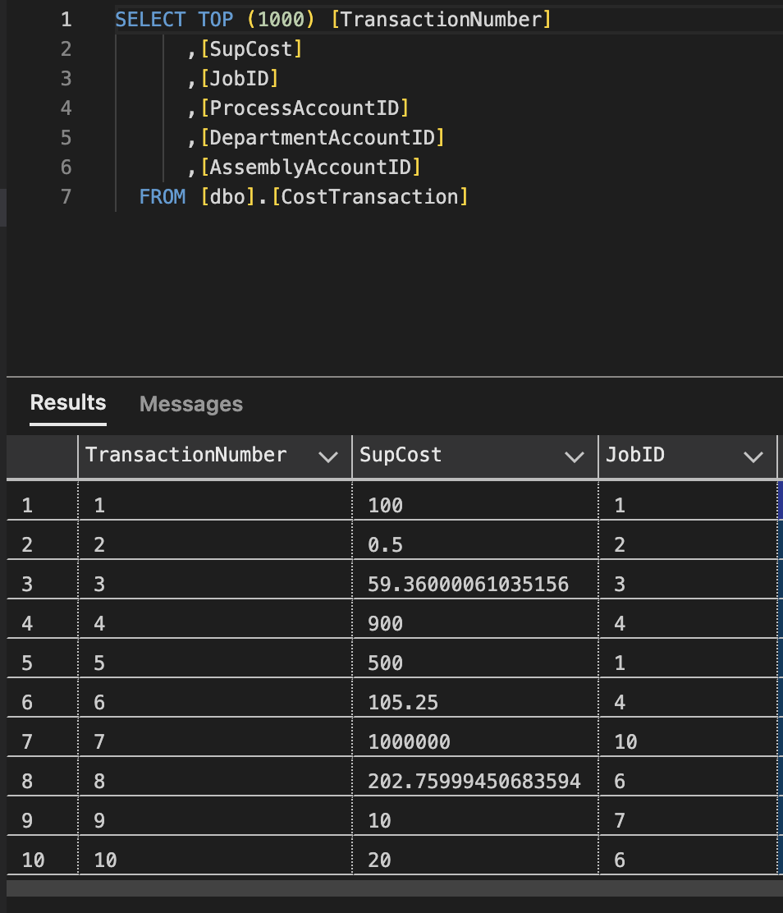

Task 6.9: Get Assembly Costs

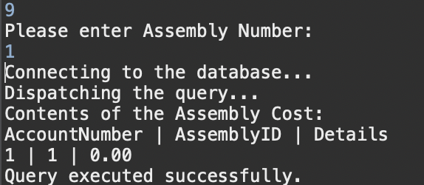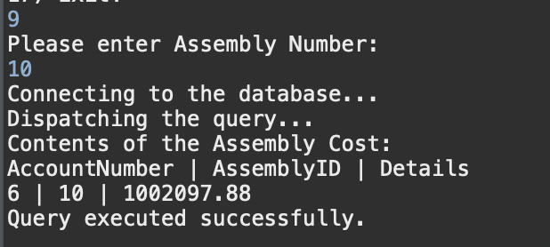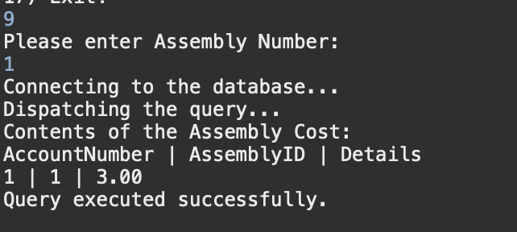

Task 6.10: get department hours

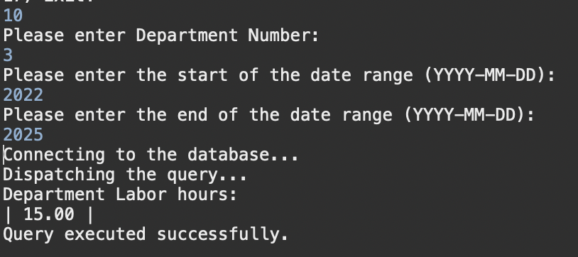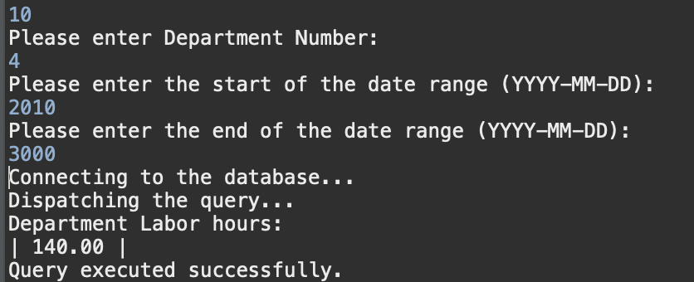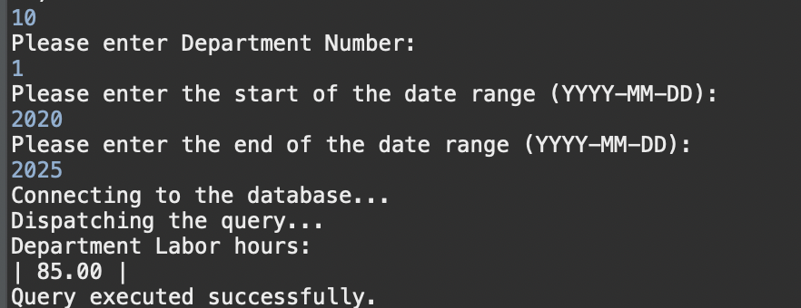

Task 6.11: get completed processes for assembly

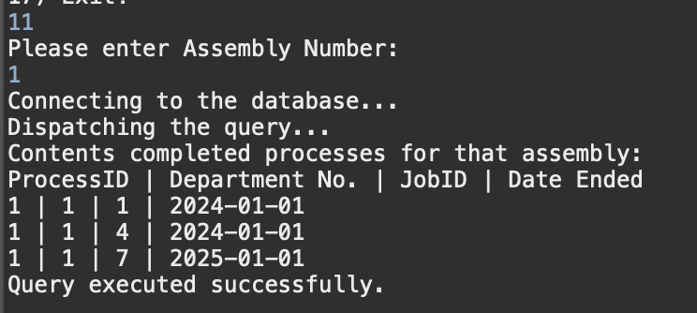

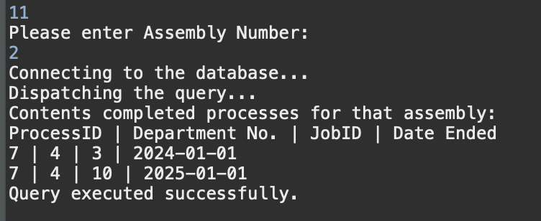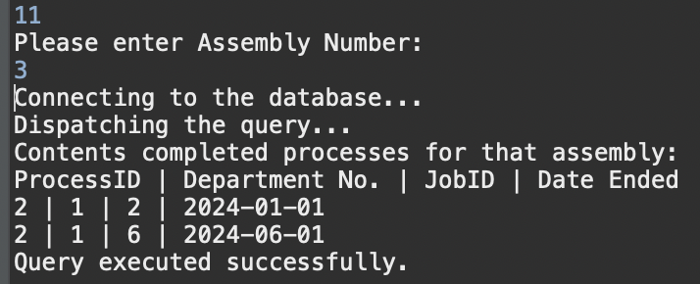

Task 6.12: Get customers by category

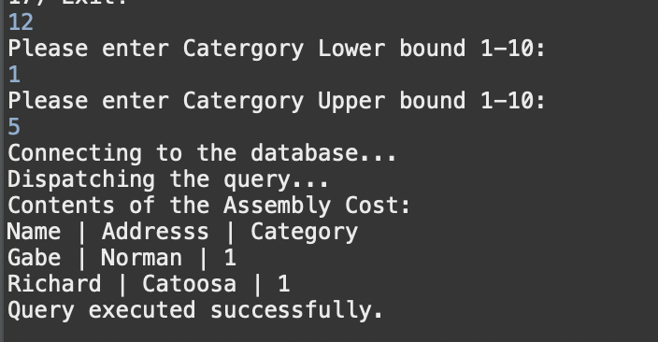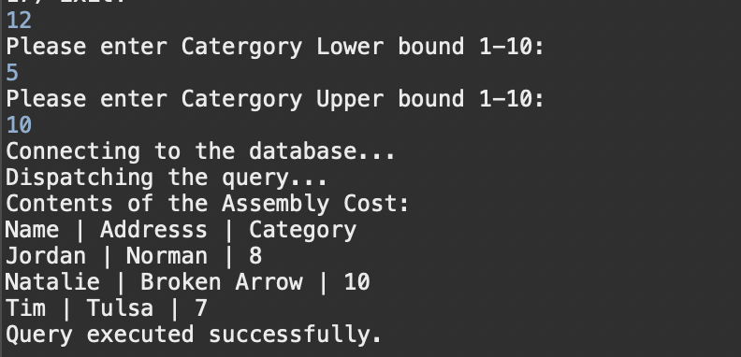

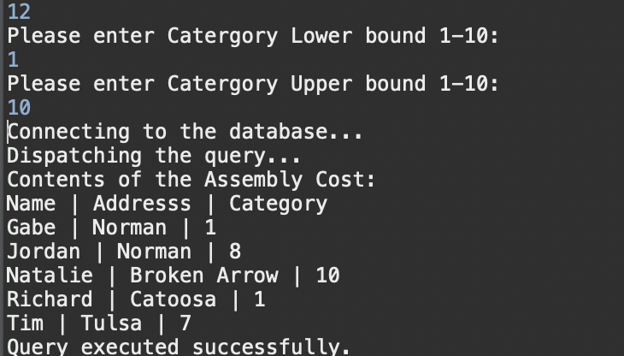

Task 6.13: Delete Cut jobs



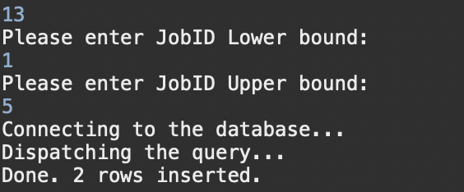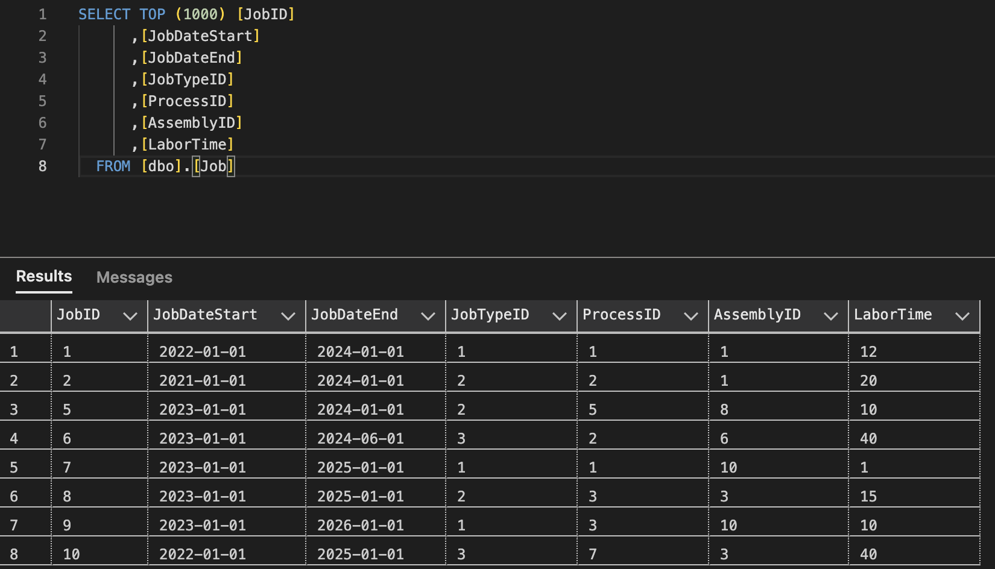

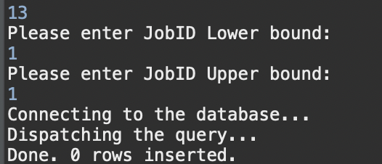



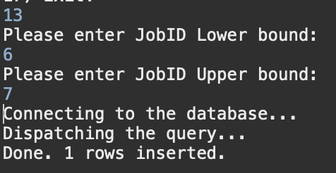

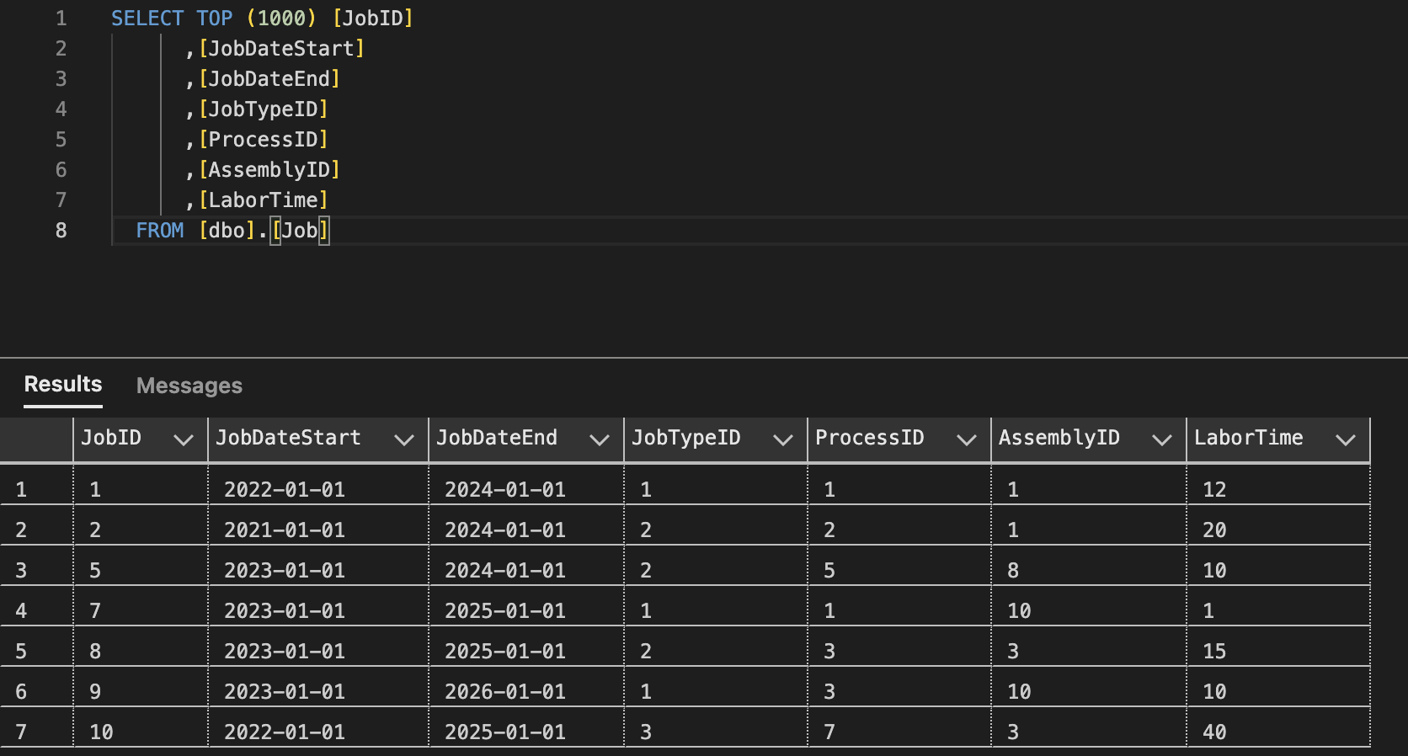

Task 6.14: Change color

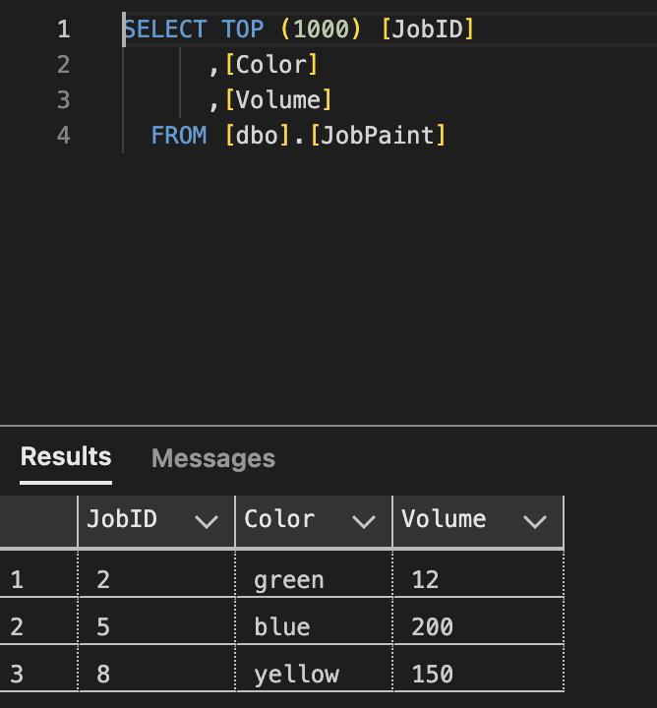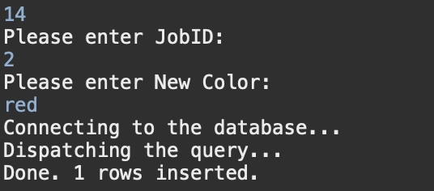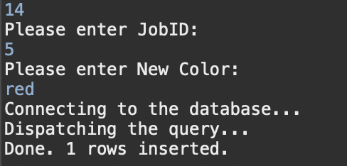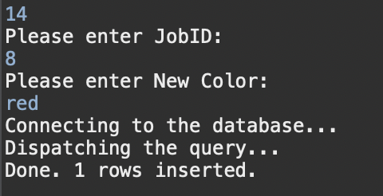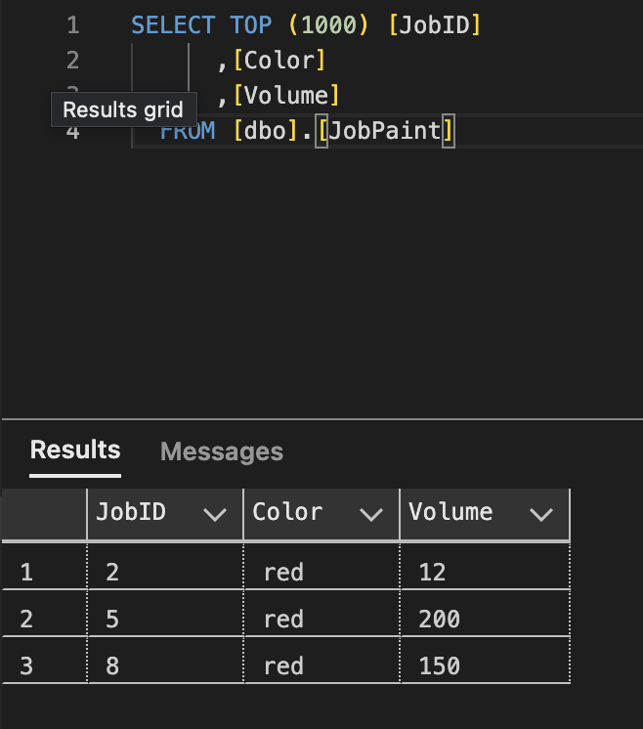

Task 6.15: Import CSV of customers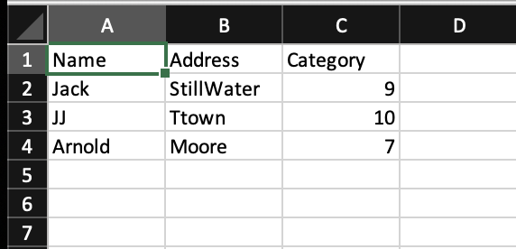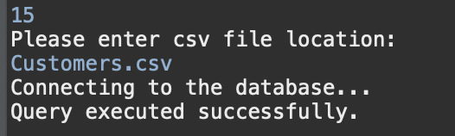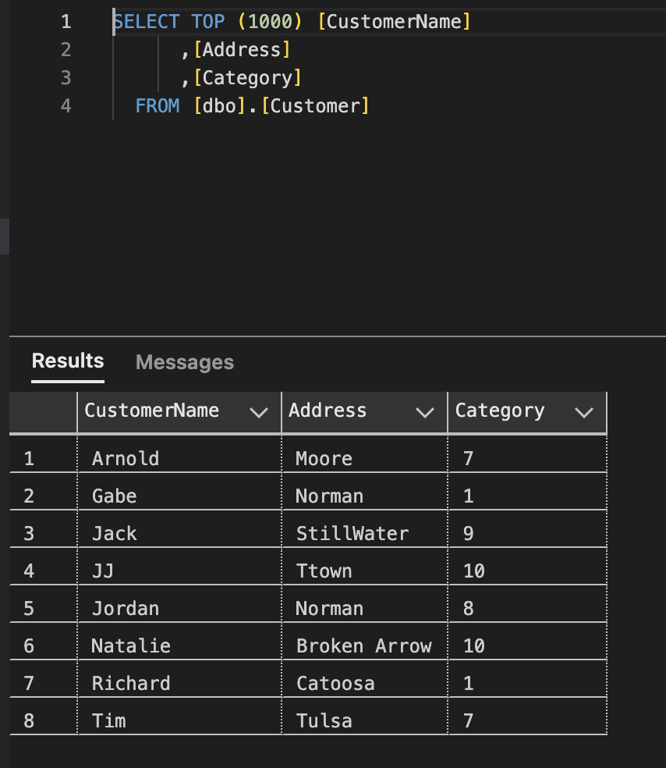

Task 6.16: export csv

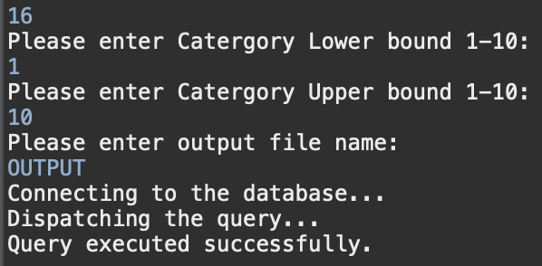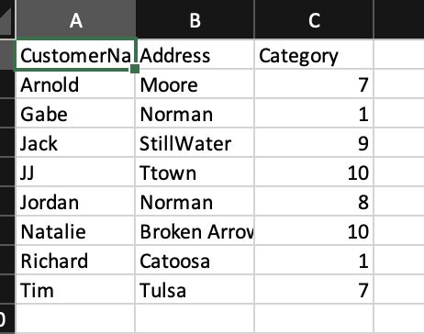

Task 6.17: Quit

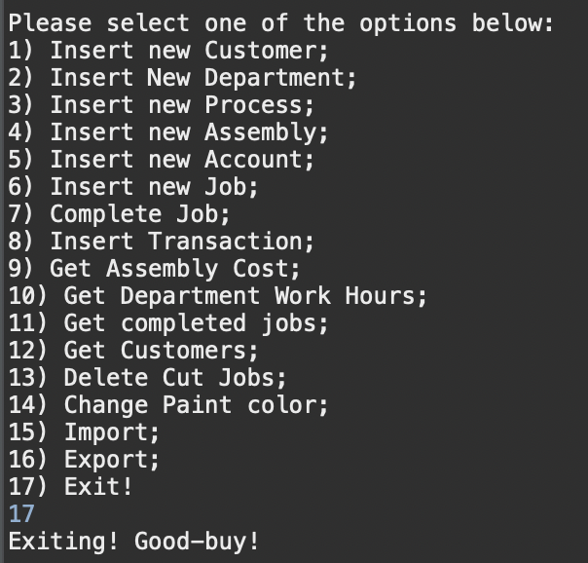

Task 7:

